Chess Test Plan

1. When you run ChessGame.main(), you are prompted by the GUI to type in the name of the first player, second player, and if you wish to start the game with the default board. We will assume Player 1’s name is a and Player 2’s name is b.

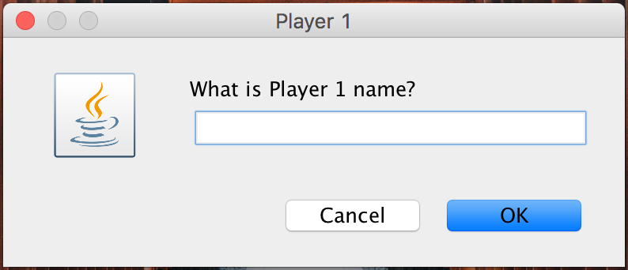

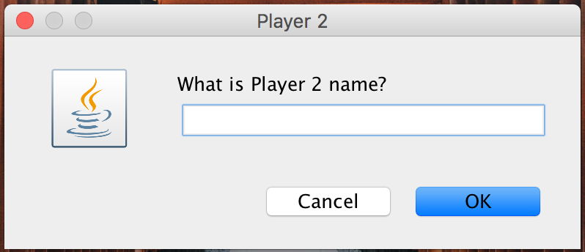

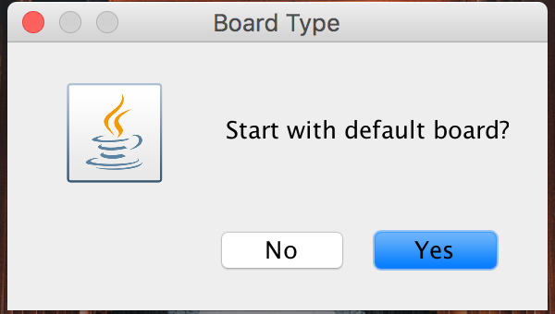

1. If you press no, the user is prompted to create their custom game. They are asked to enter in the number of rows and columns on their board, the pieces they would like on their board and the location of those pieces, and then the user enters done when completed setting up their custom board.

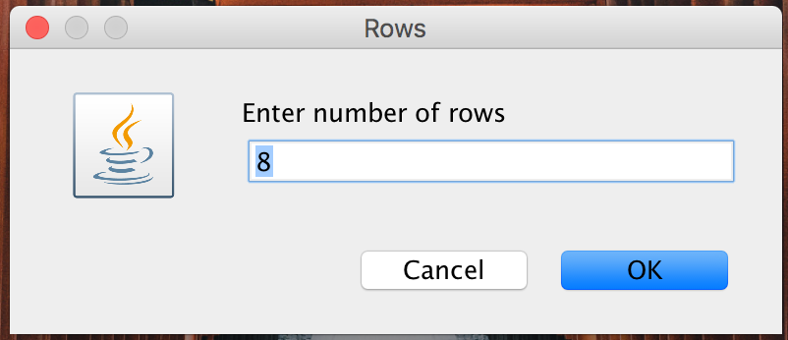

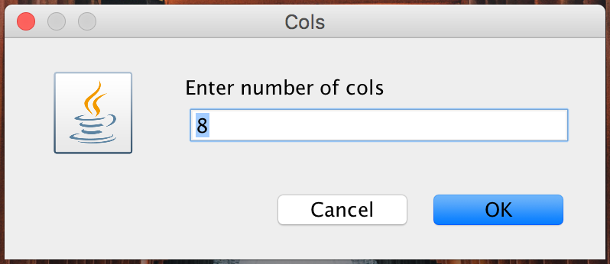

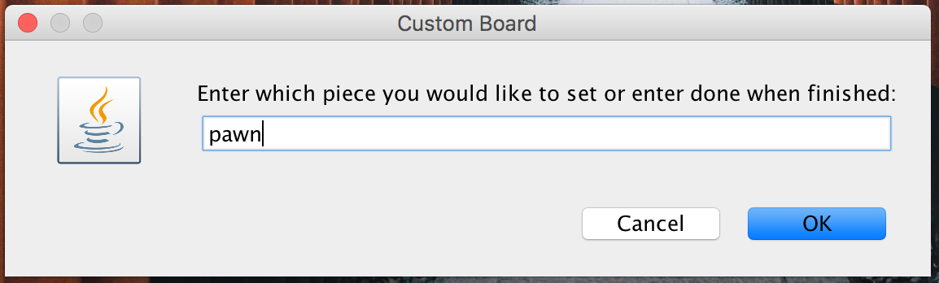

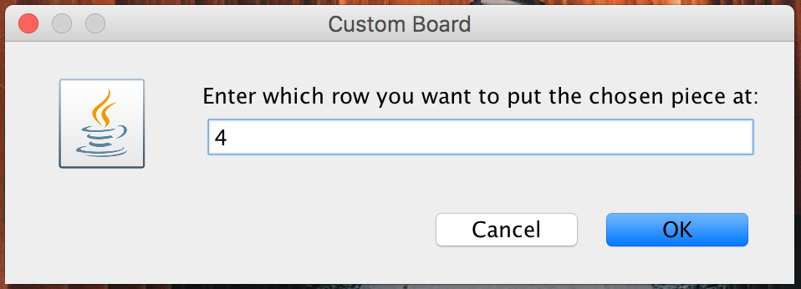

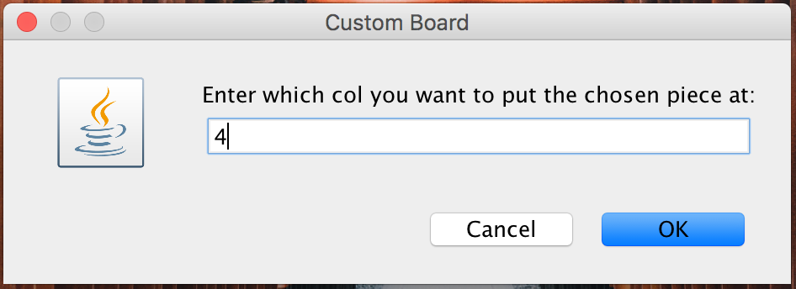

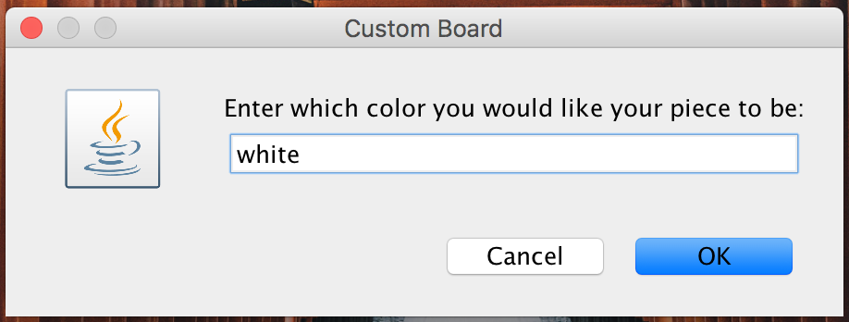

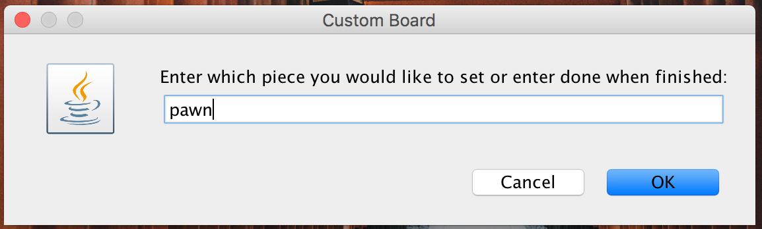

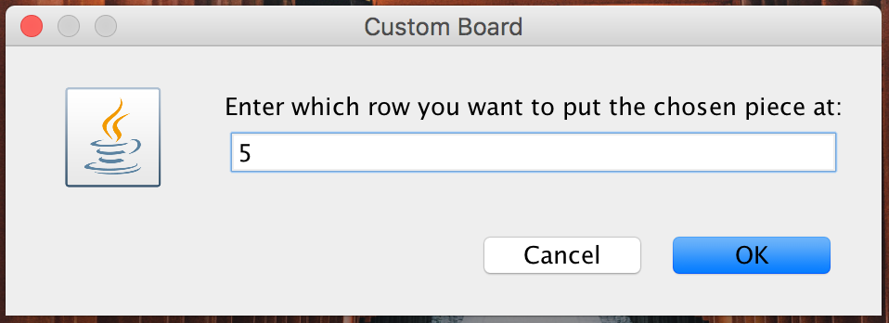

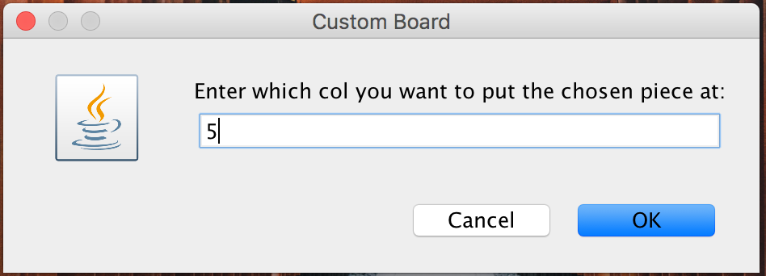

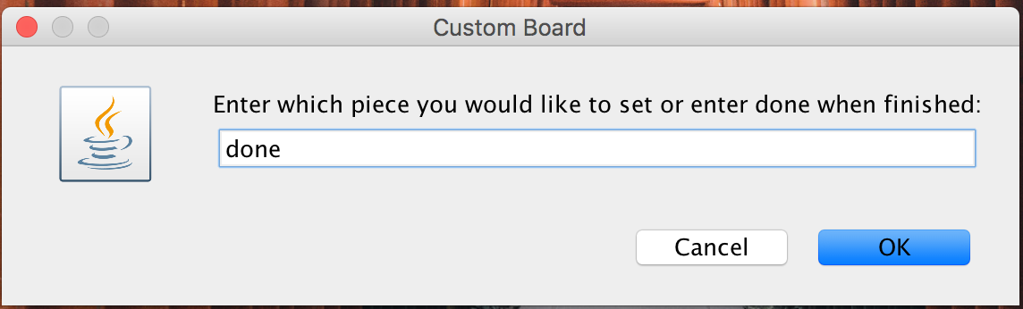

Assuming, the player is done finishing the board set up after placing one black pawn and one white pawn on the board, the custom board would look like this:

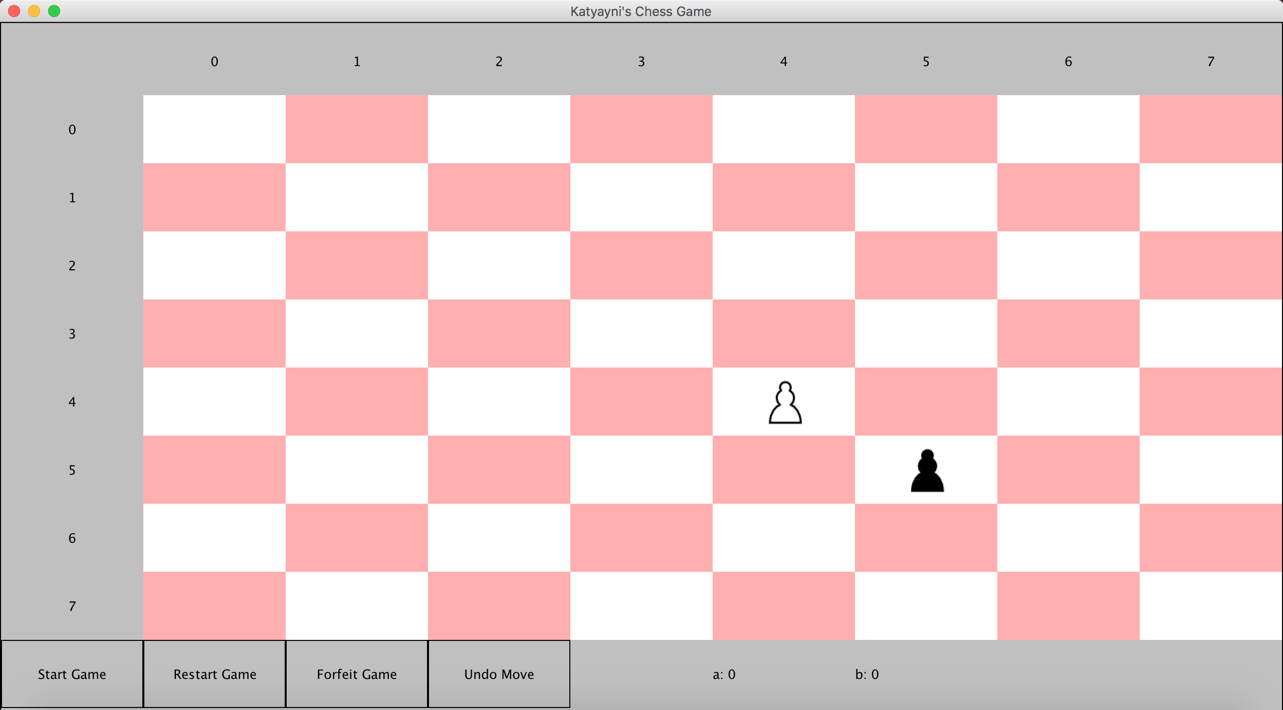

1. In the case, the user does choose to use the default board, the user will see the following board. Note, clicking any square on the board or piece will not do anything until the use clicks start game. There are buttons for starting the game, restarting the game, forfeiting the game, and undoing a move.

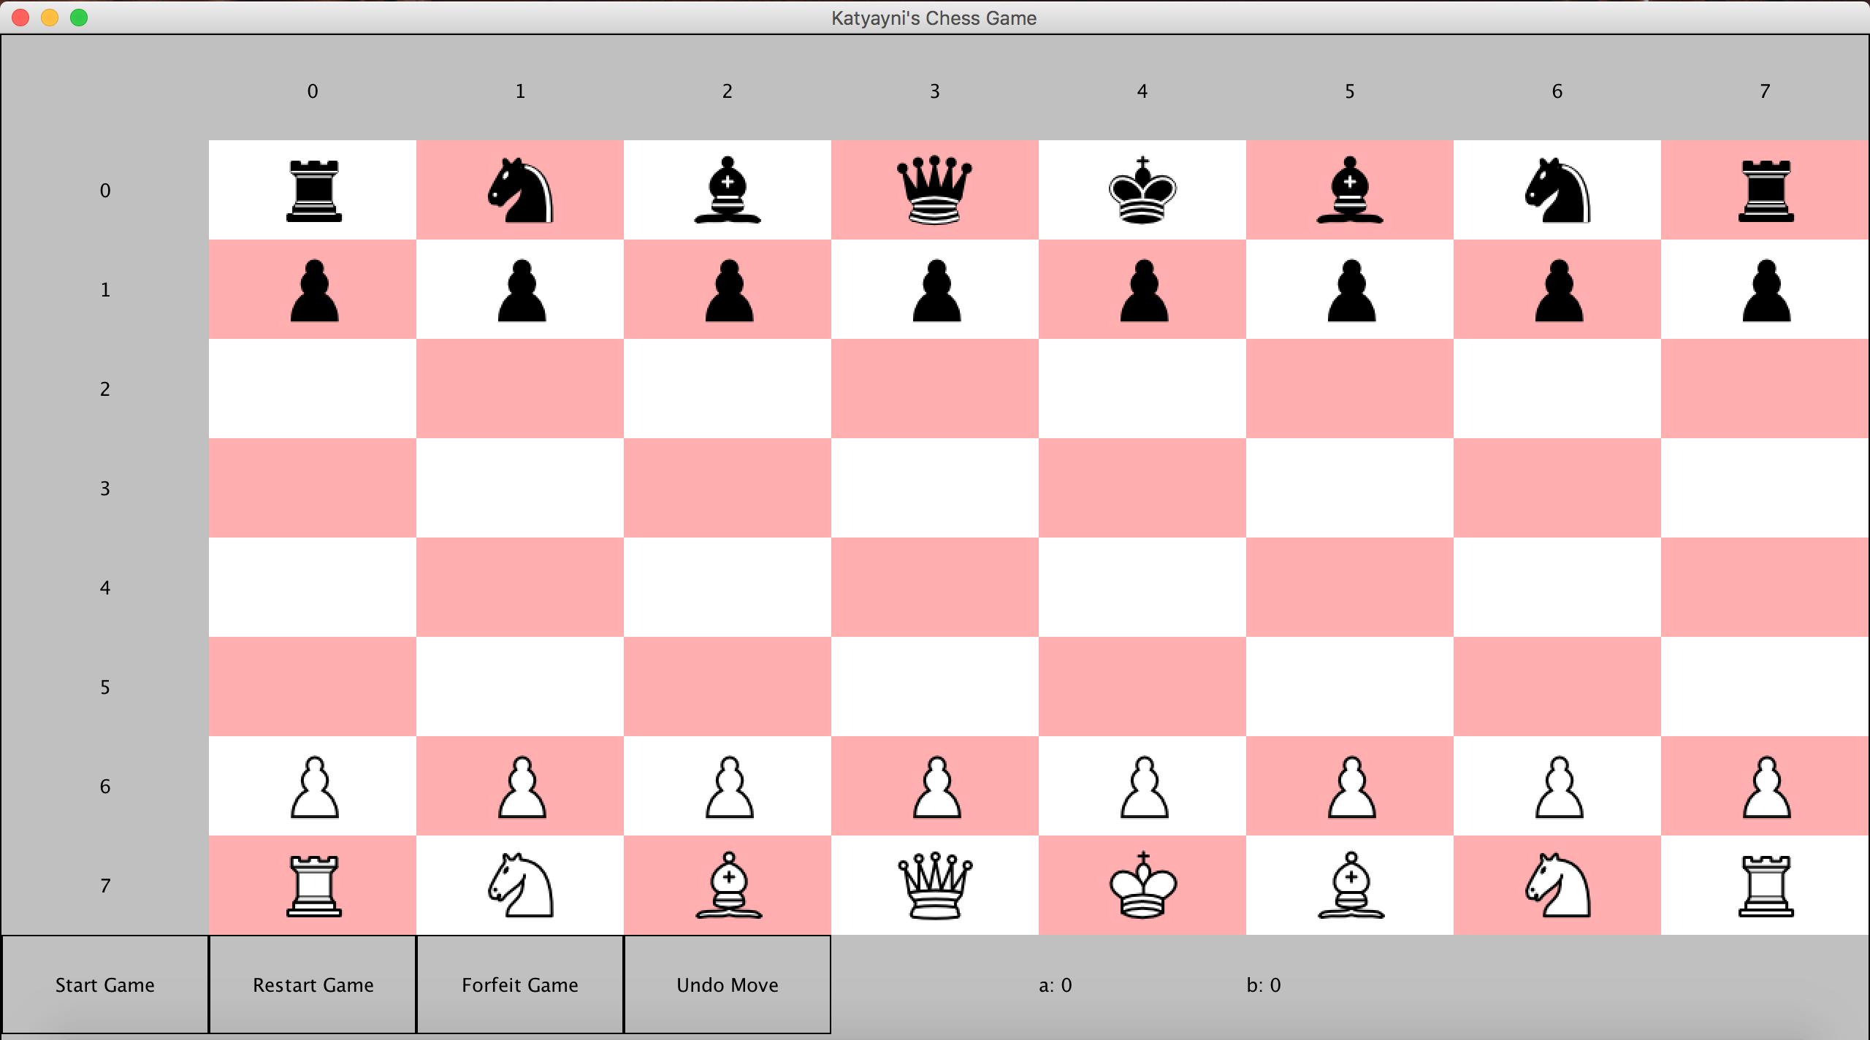

1. When you click start game, it is automatically first White’s move. Player 1 will always be White by design. Whoever’s turn it is, is listed at the bottom pane next to the buttons.

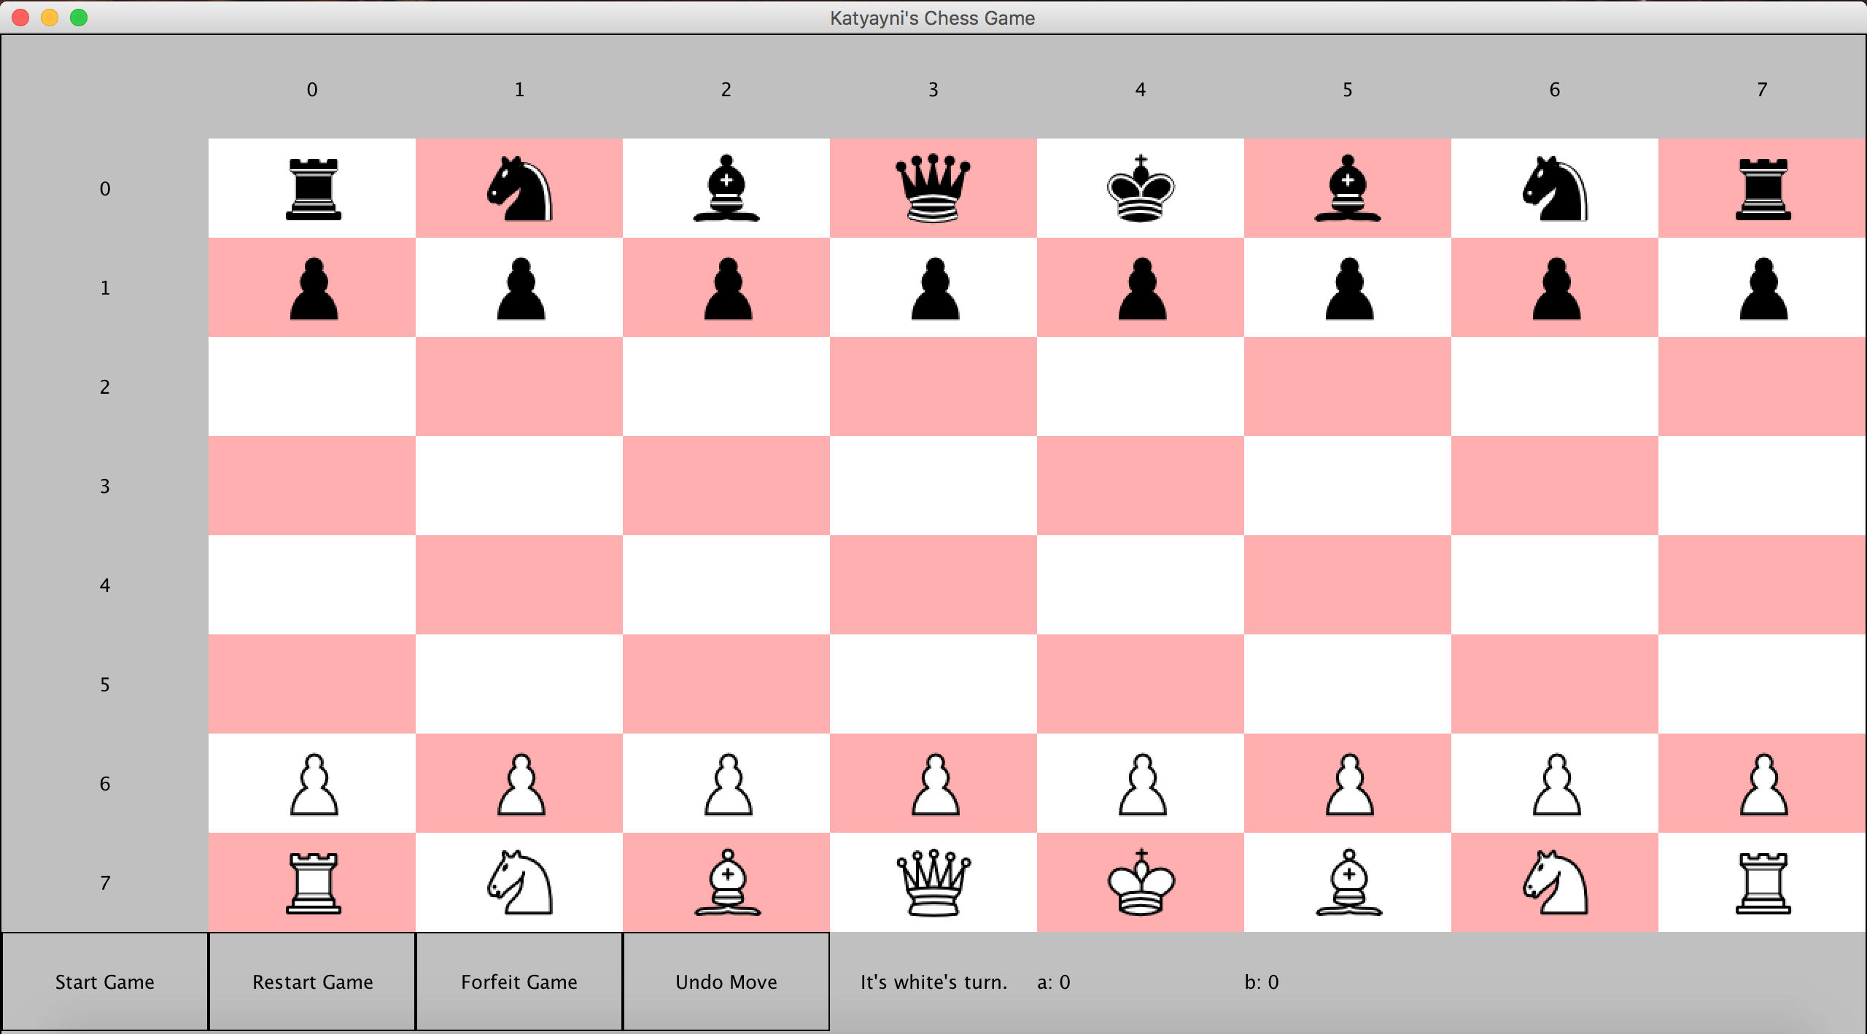

1. If you click an empty coordinate without clicking on a piece, nothing happens.
2. Clicking on a piece that is not your piece to move, will prompt an alert letting you know that you were attempting to move a piece not controlled by your team.

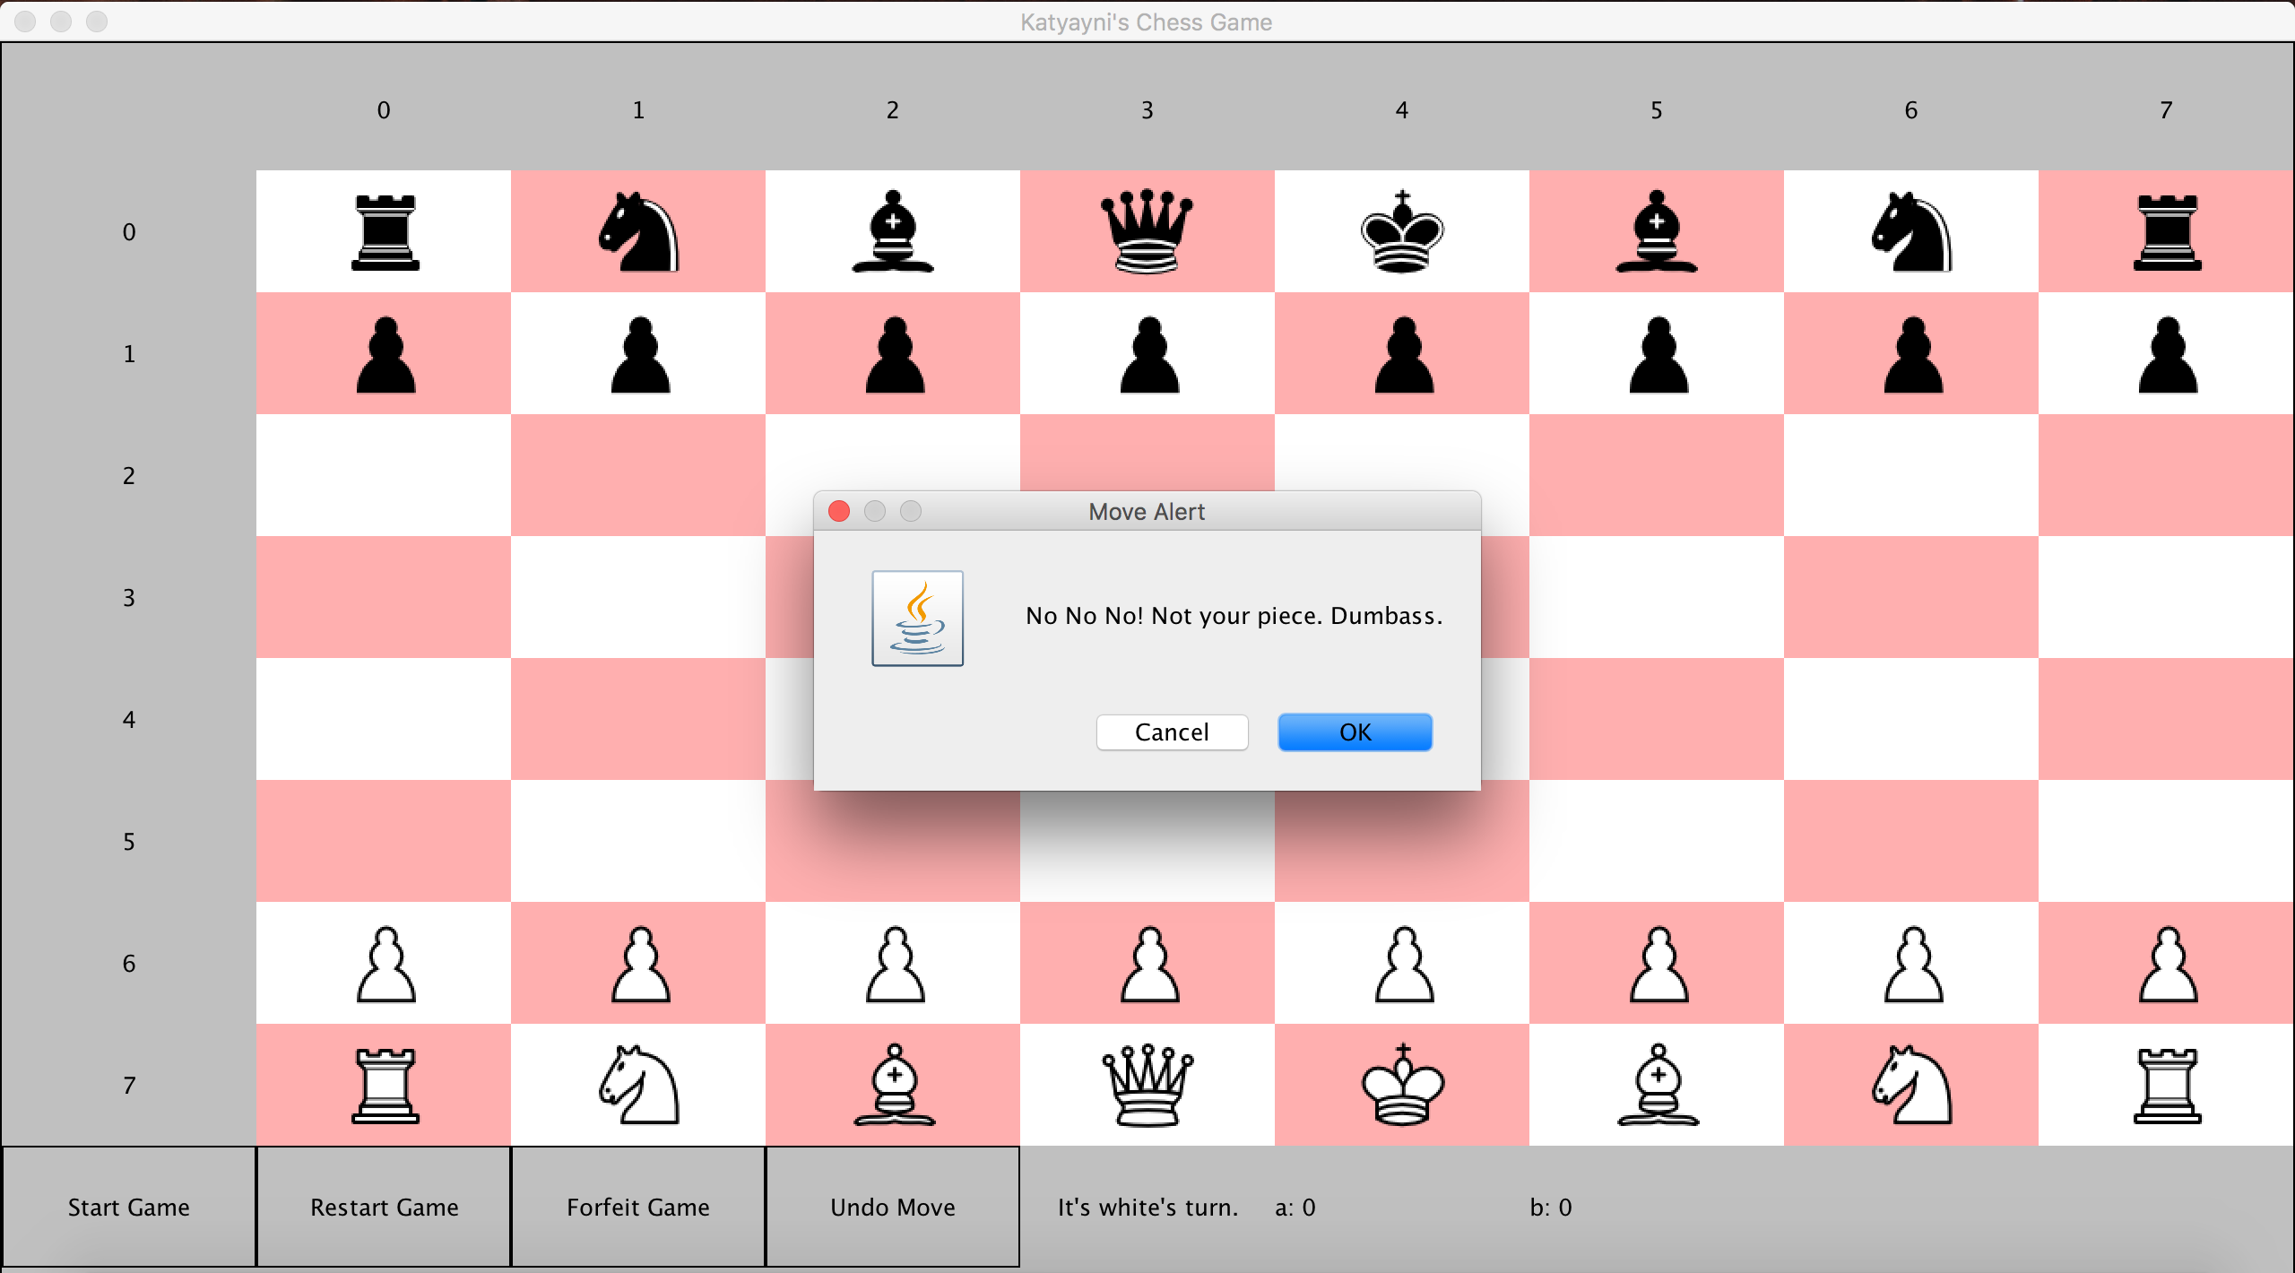

1. When you click on your teams’ piece to move, the selected piece will be highlighted in orange and all of the piece’s possible moves will be highlighted in teal.

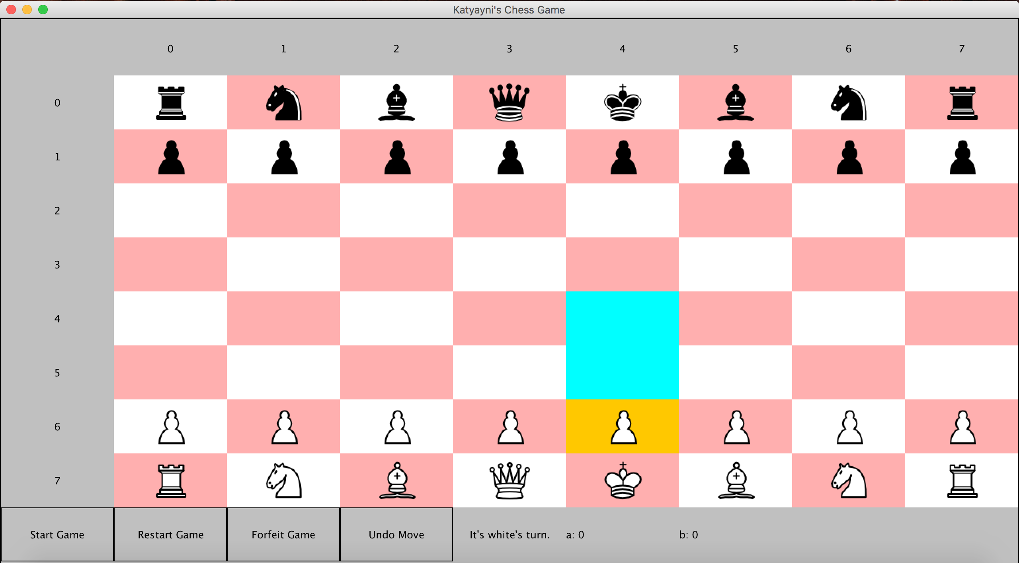

1. If I attempt to move the piece to an invalid destination, an alert will be prompted telling the user that they cannot move there.

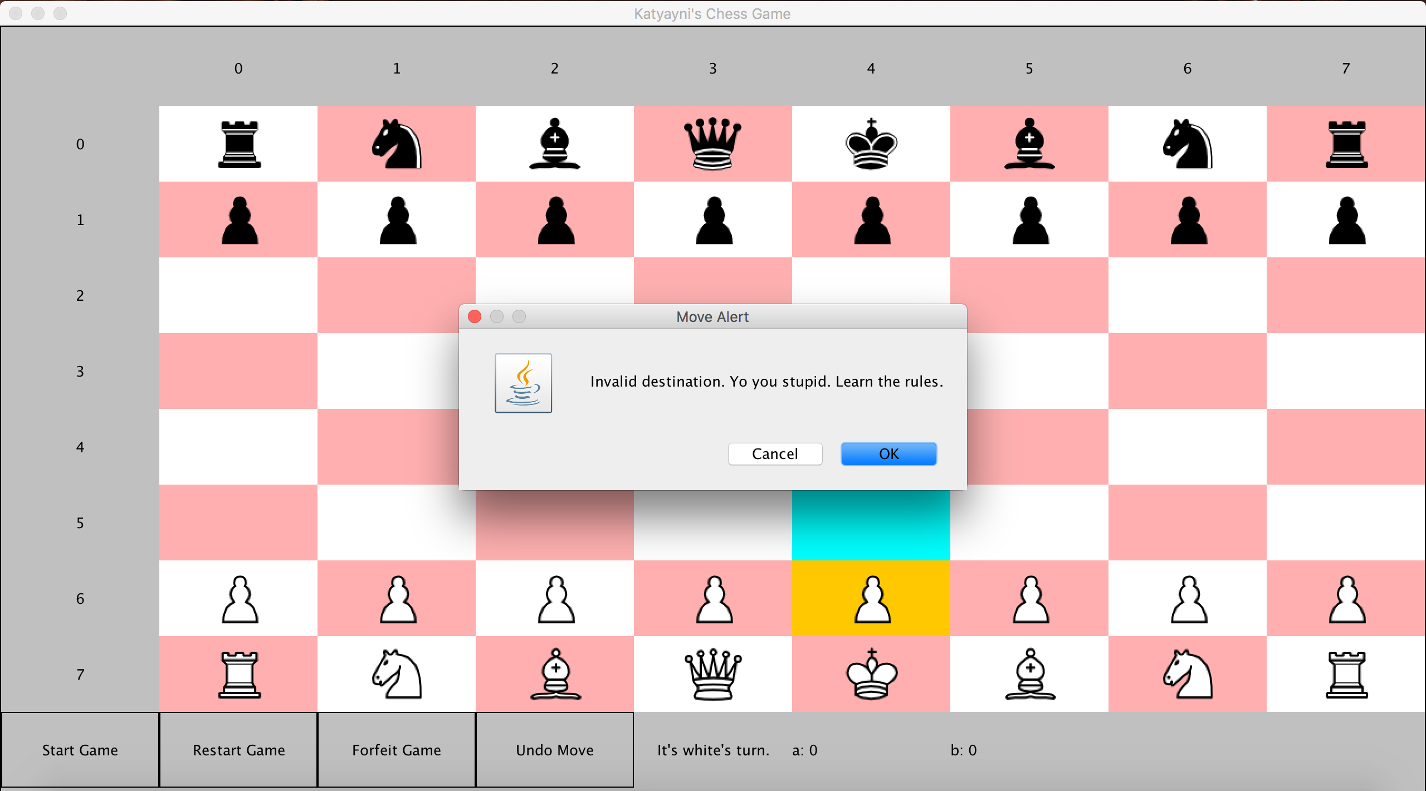

1. When a valid destination is selected, the piece will move there, the highlight colors will reset, and the turn switches to the opposite team. In the screenshot below, you will see that now it says that it’s the other teams turn.

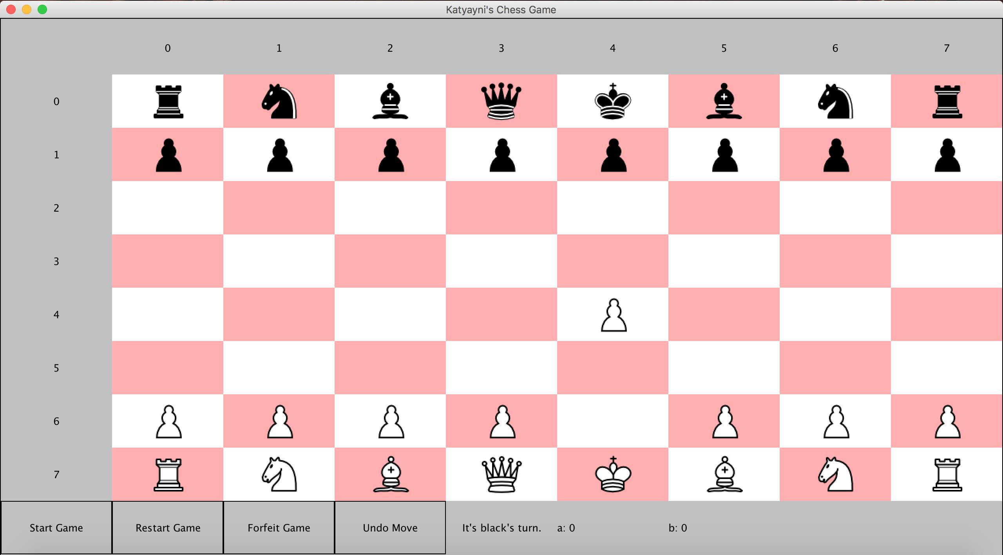

1. Other team’s turn.

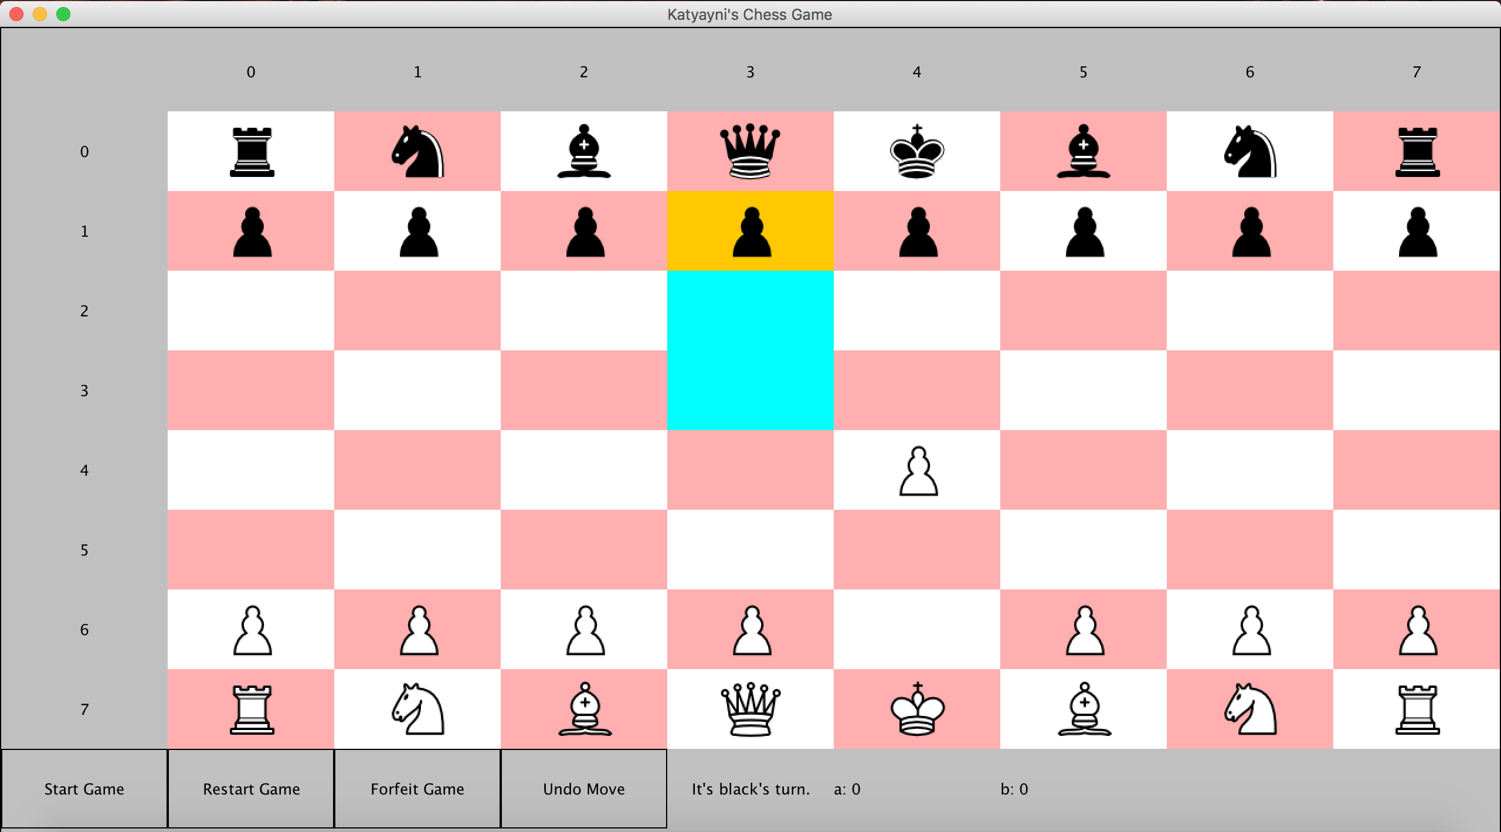

1. Capturing a piece.

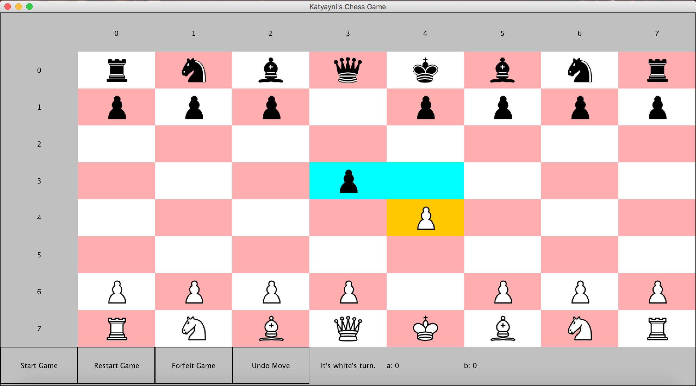

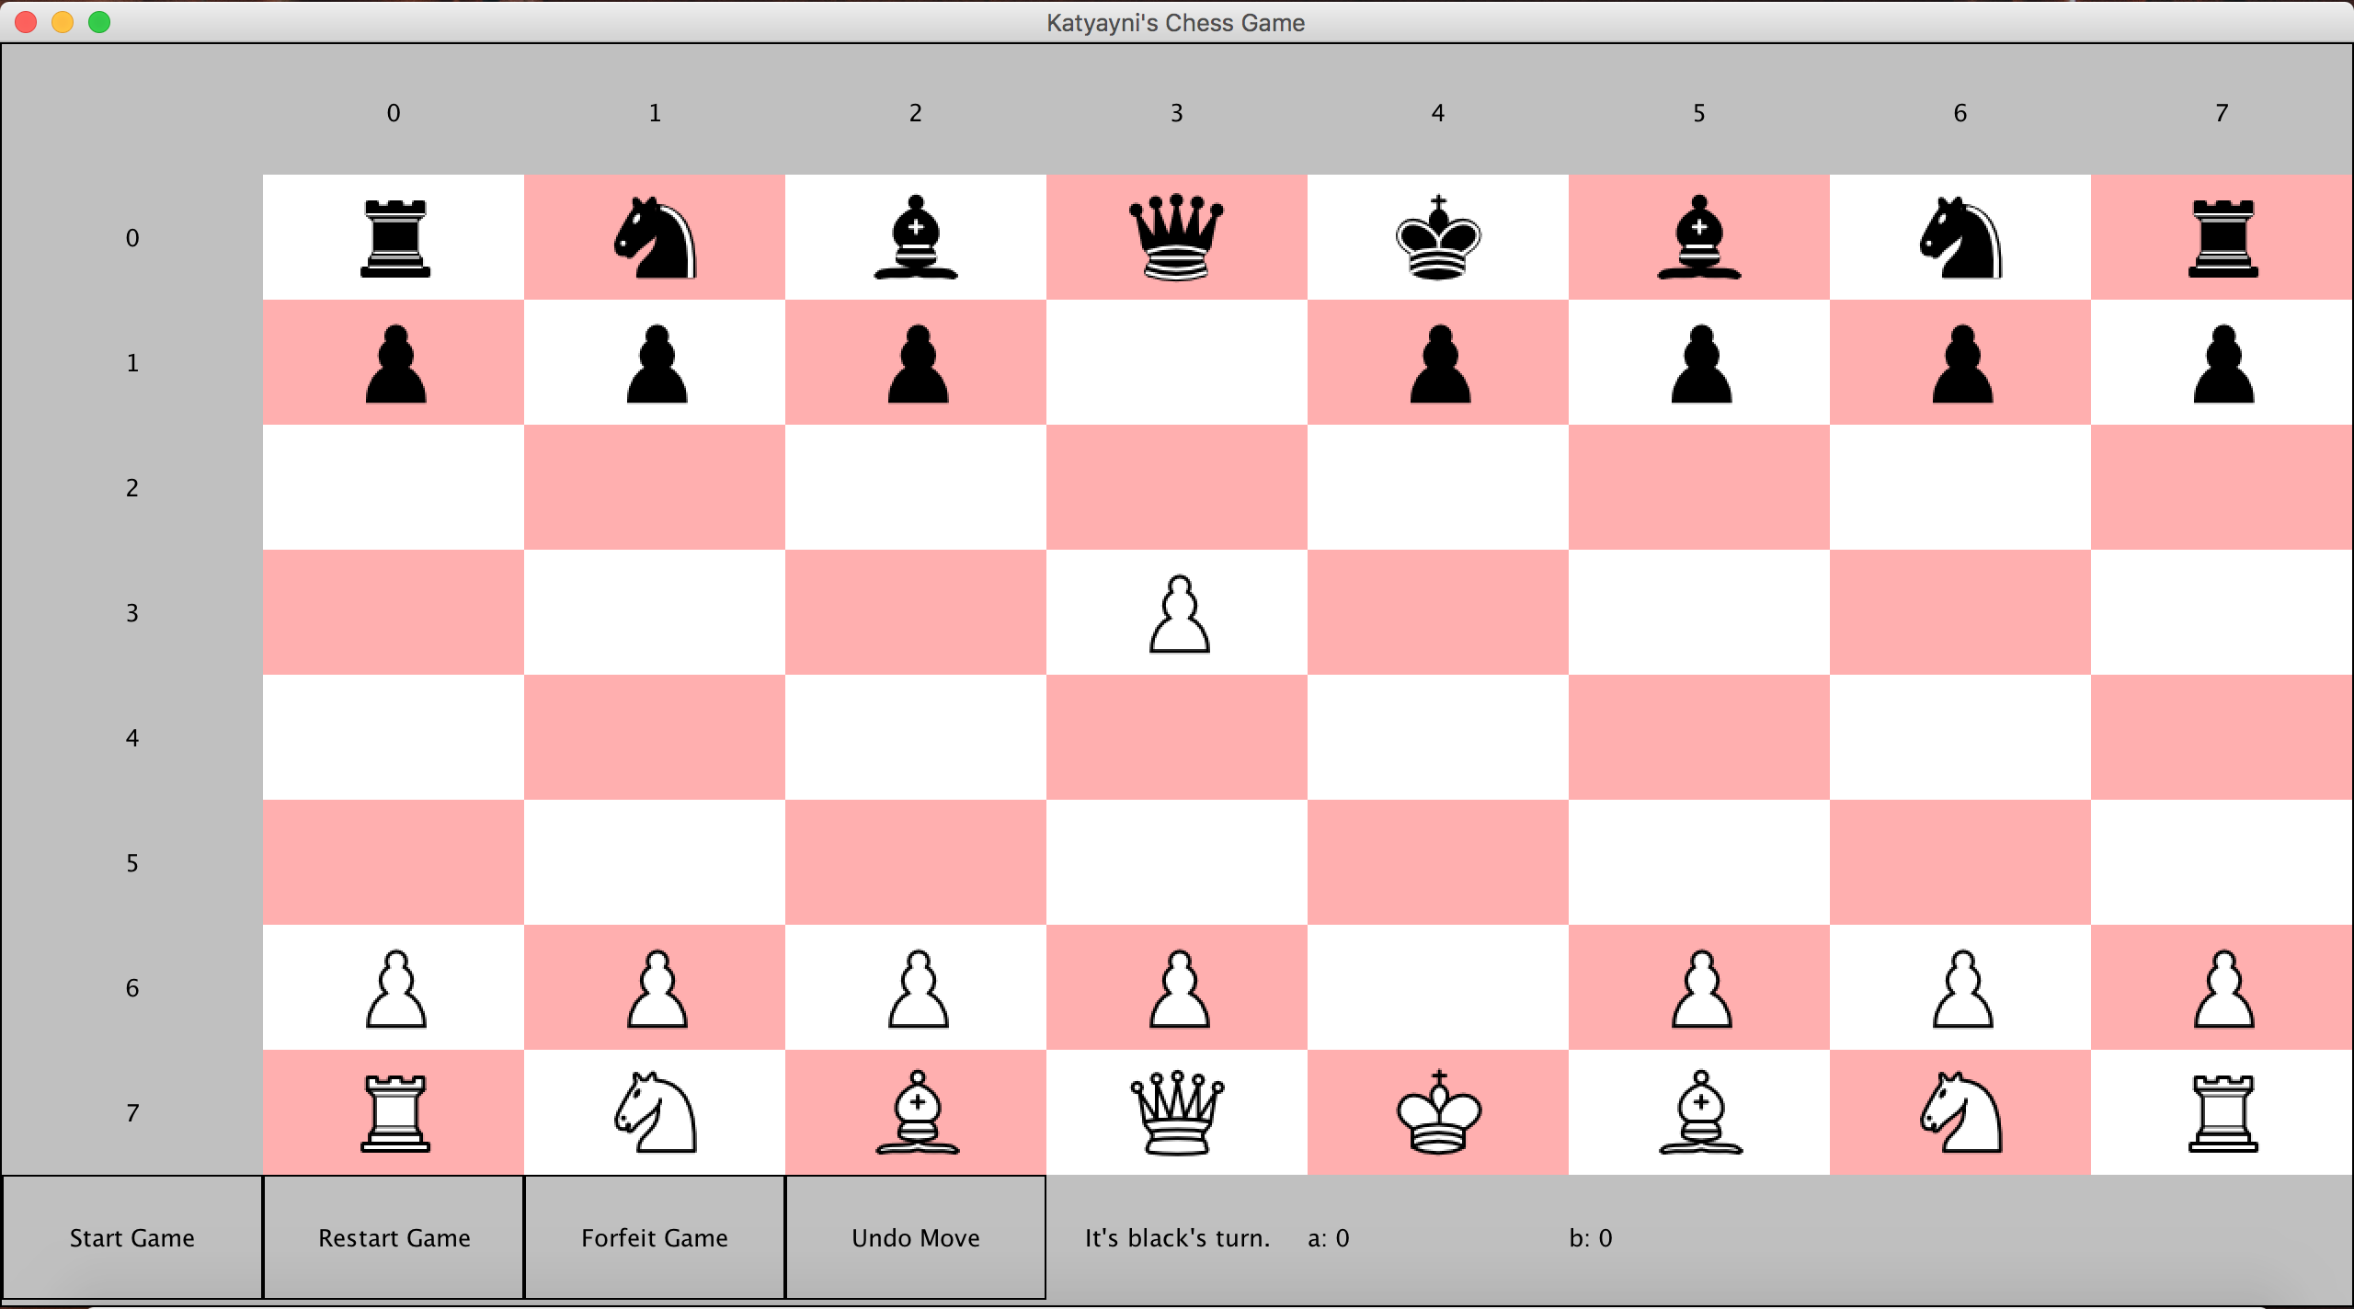

1. If a player is in Check, an alert will also inform the user.

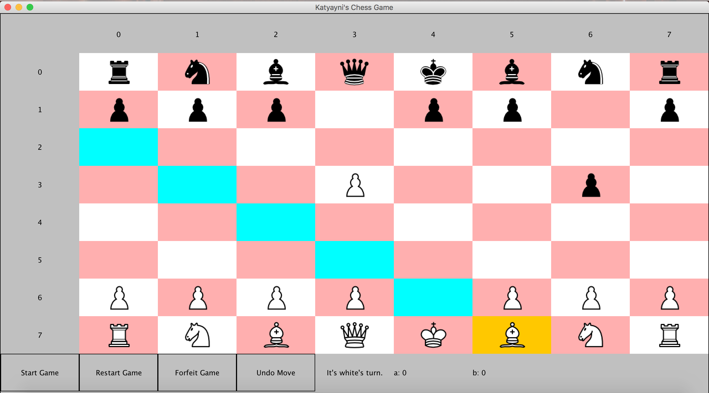

After you have selected the destination, for your piece, if you have put the other team in check, an alert comes up:

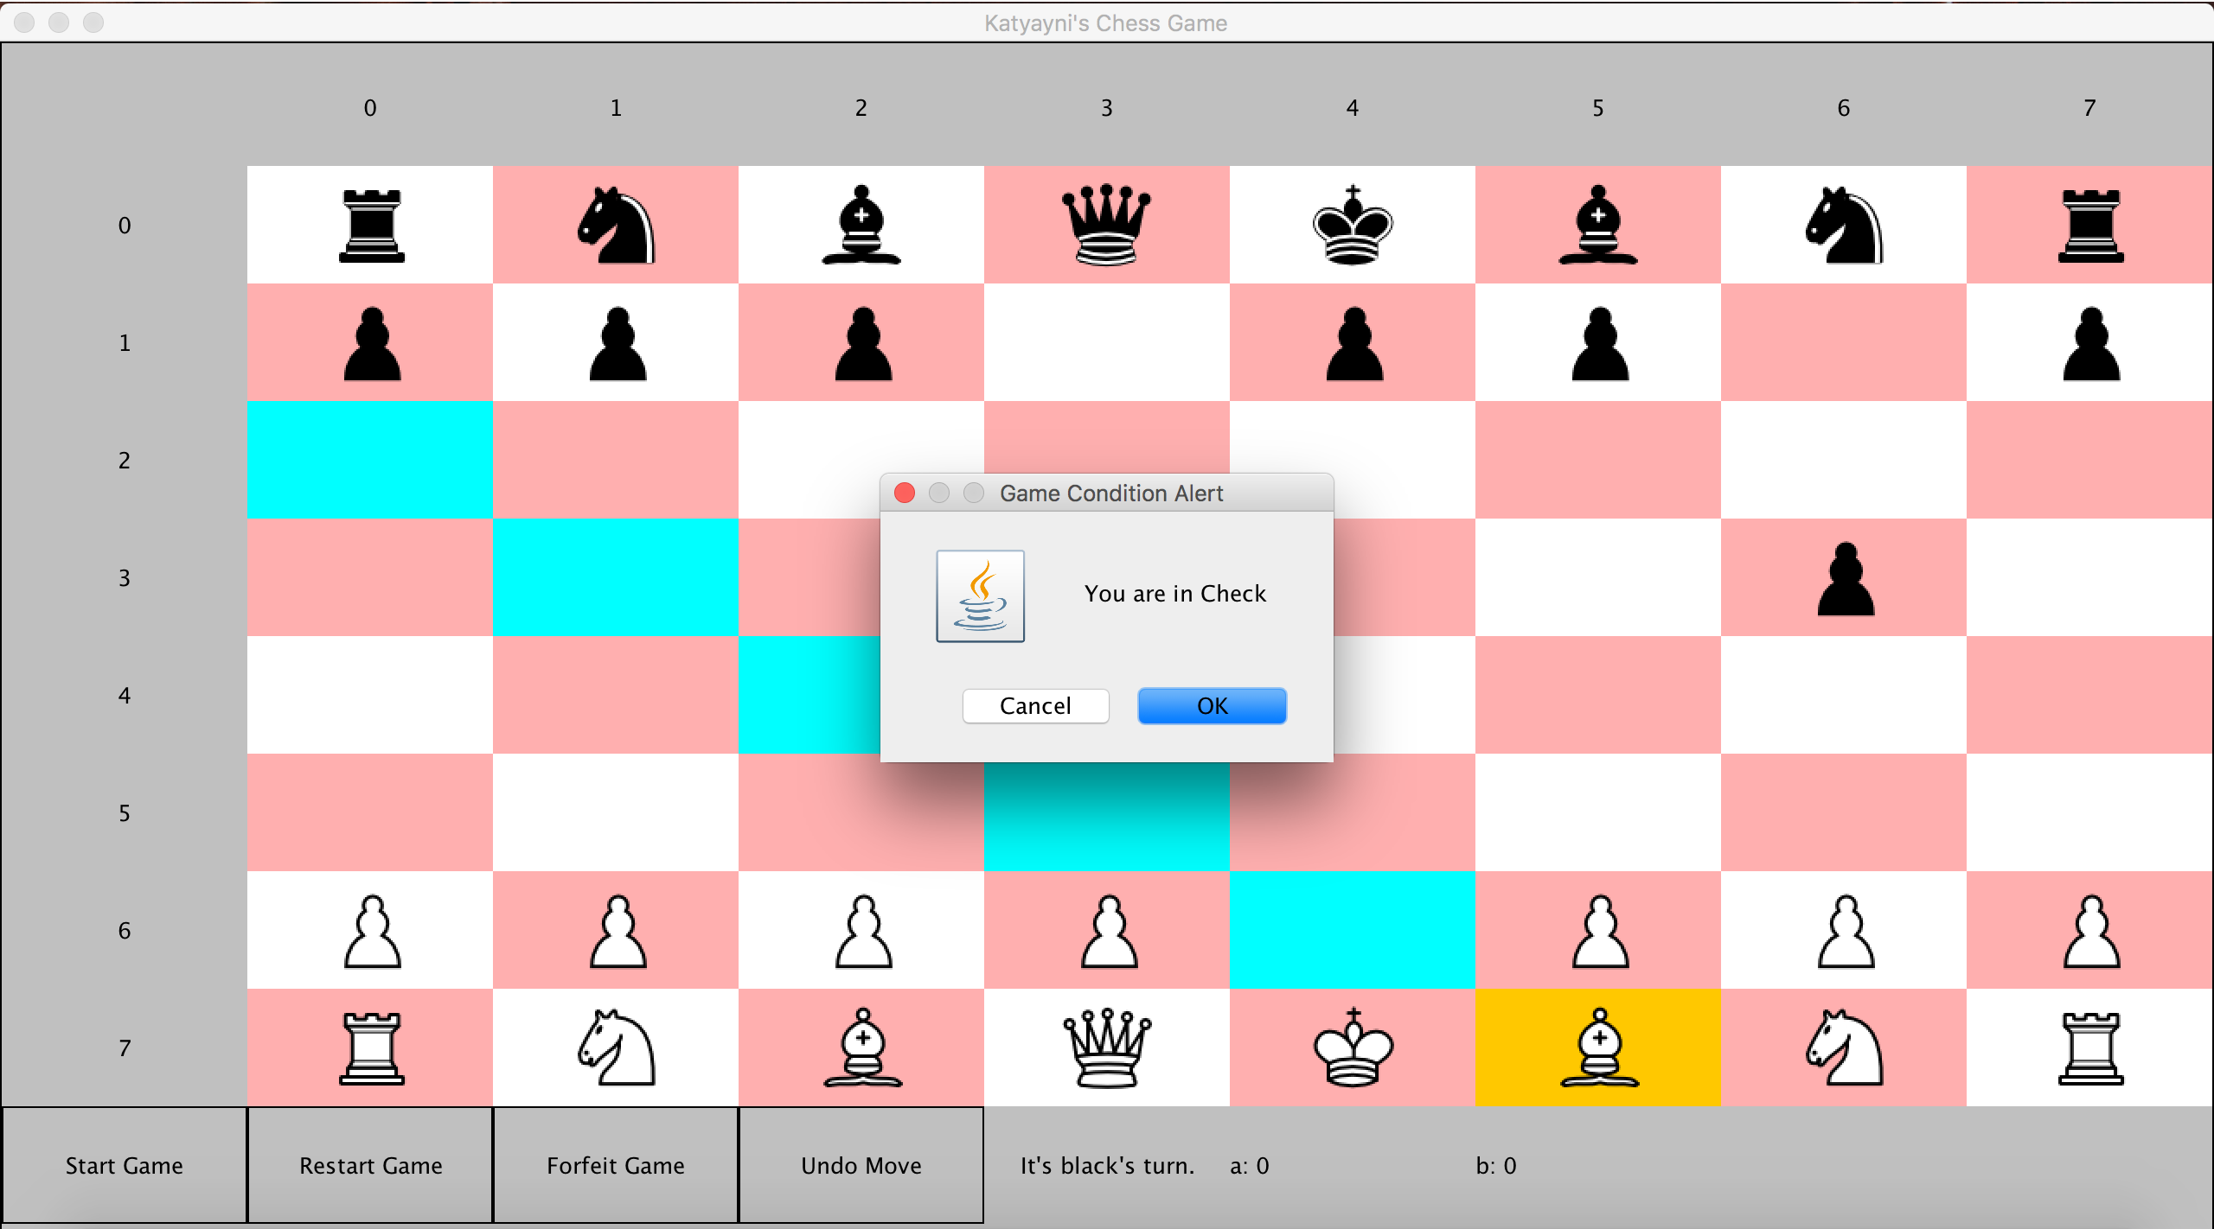

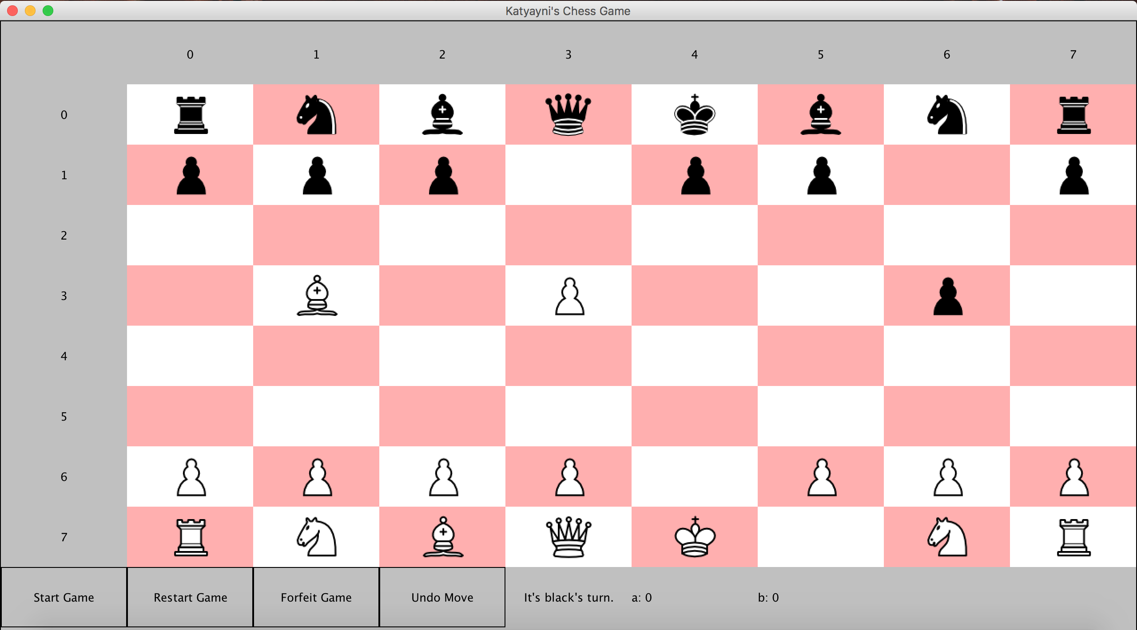

1. When in Check, if a player attempts to move somewhere that won’t take them out of Check, another alert is prompted.

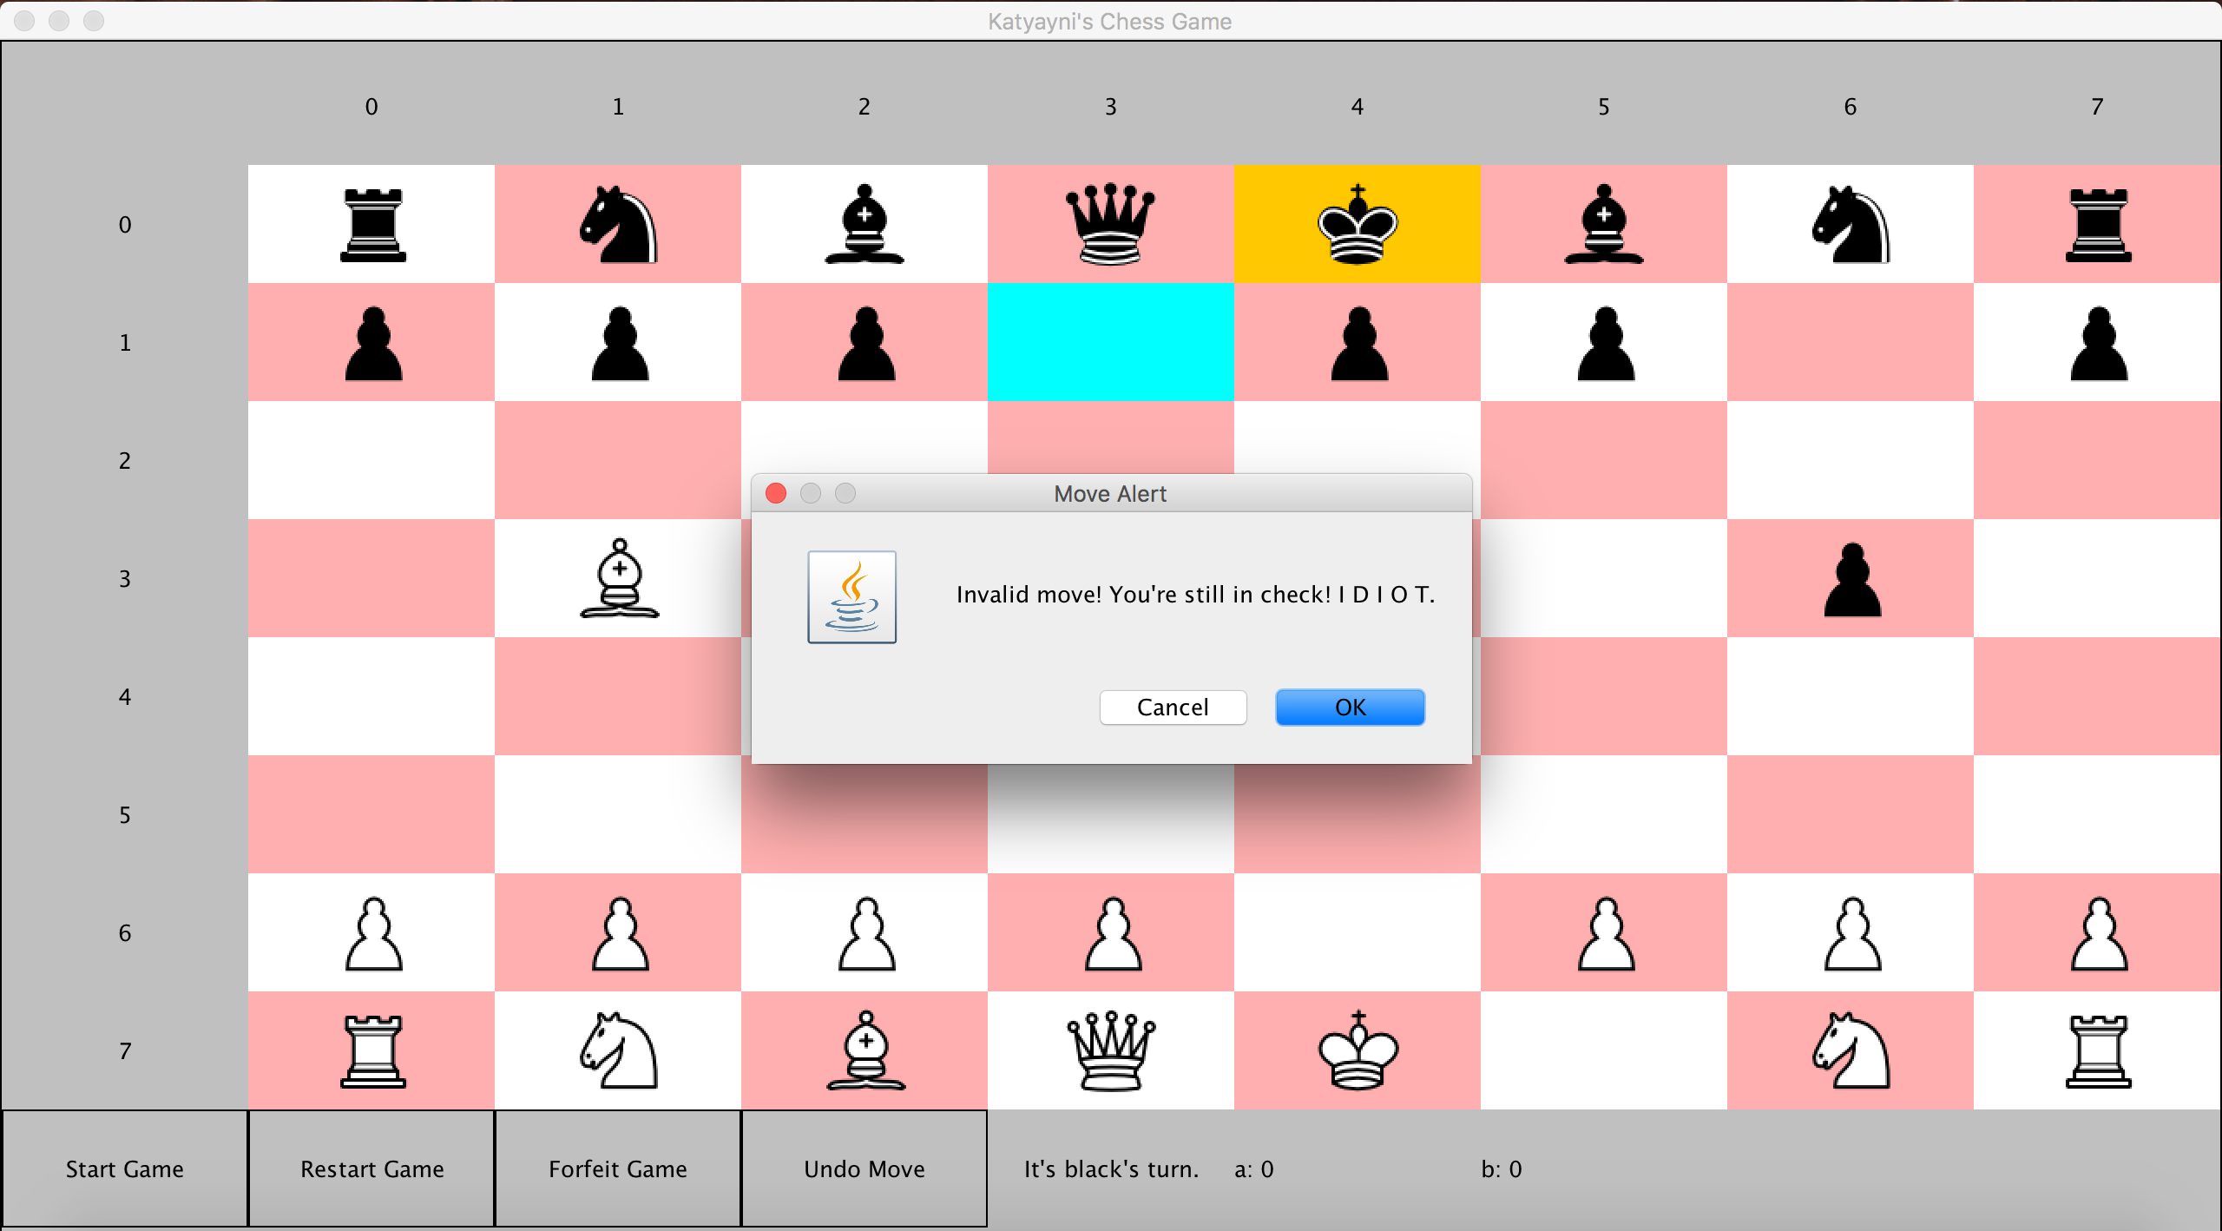

1. Black get’s out of Check. White’s turn.

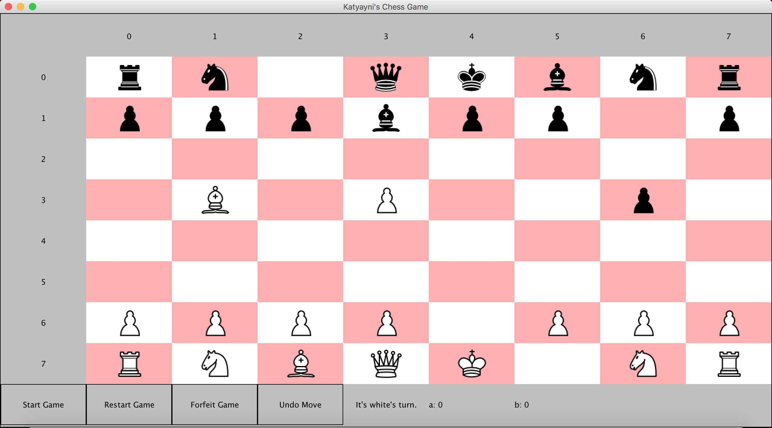

1. Scenario where black is put in checkmate and an alert comes up.

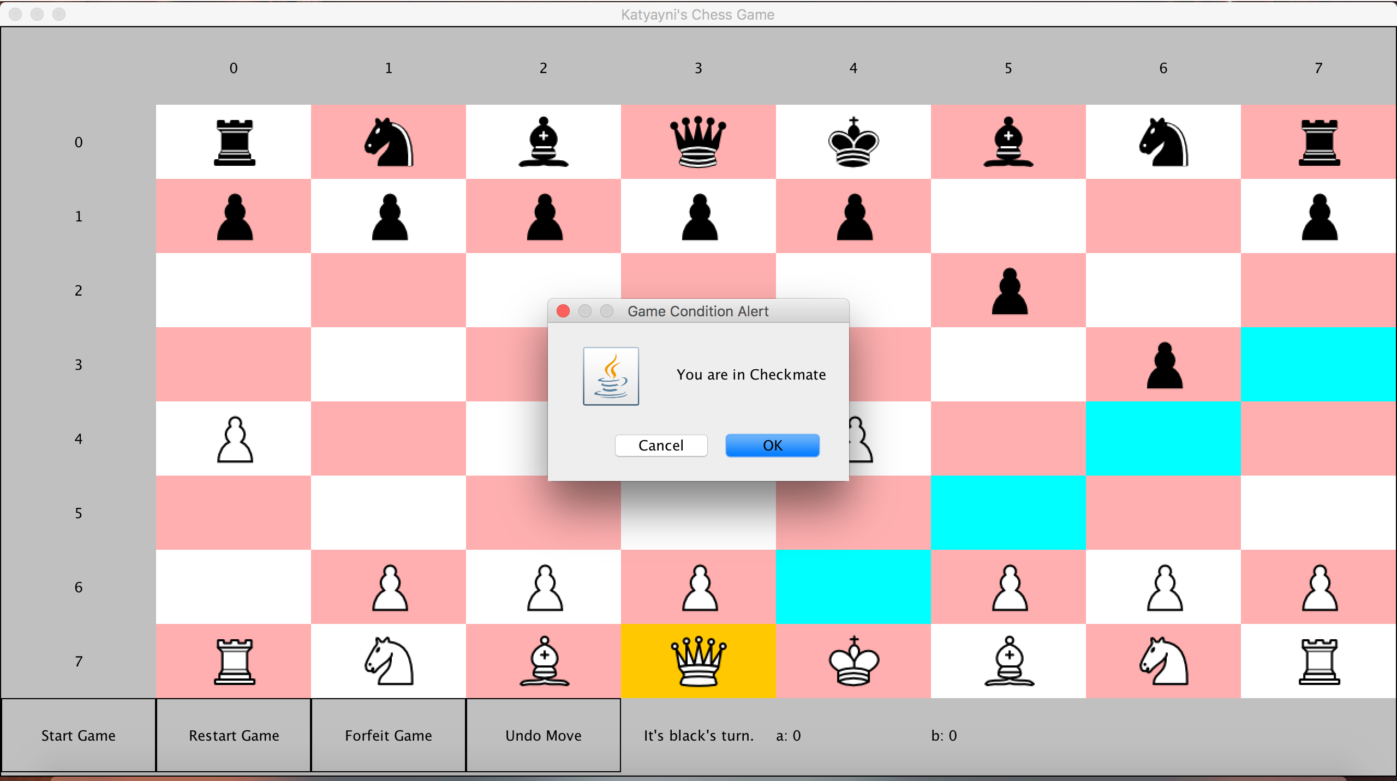

The game ends and notice that Player 1 (a)’s score increase because White won this game.

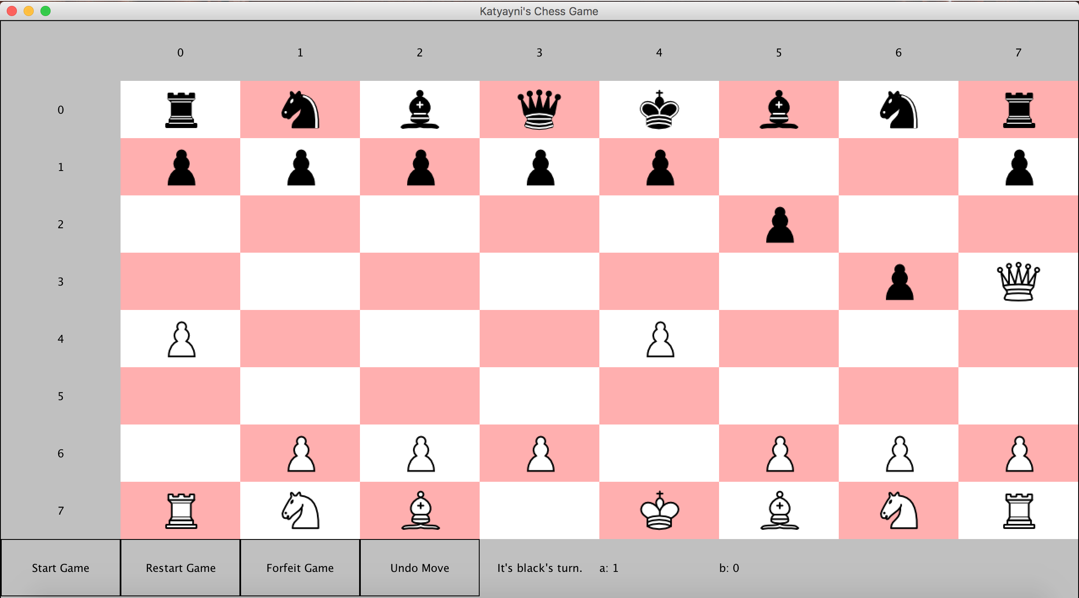

1. To start another game, a player will have to click Restart game to start another game. Start game will not restart another game by design choice. If they choose Restart, both players must agree to restart and only then will the game restart.

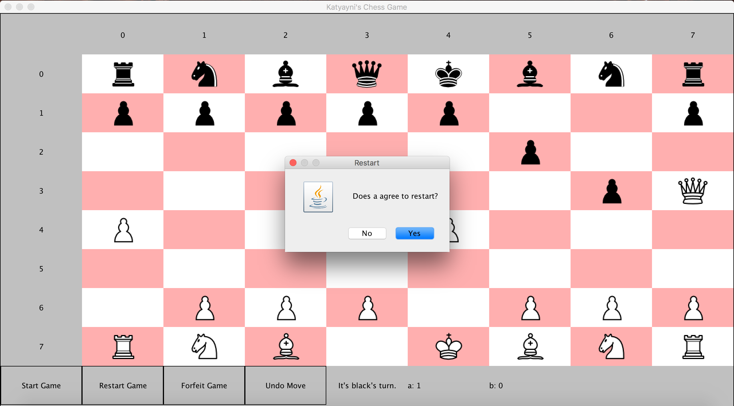

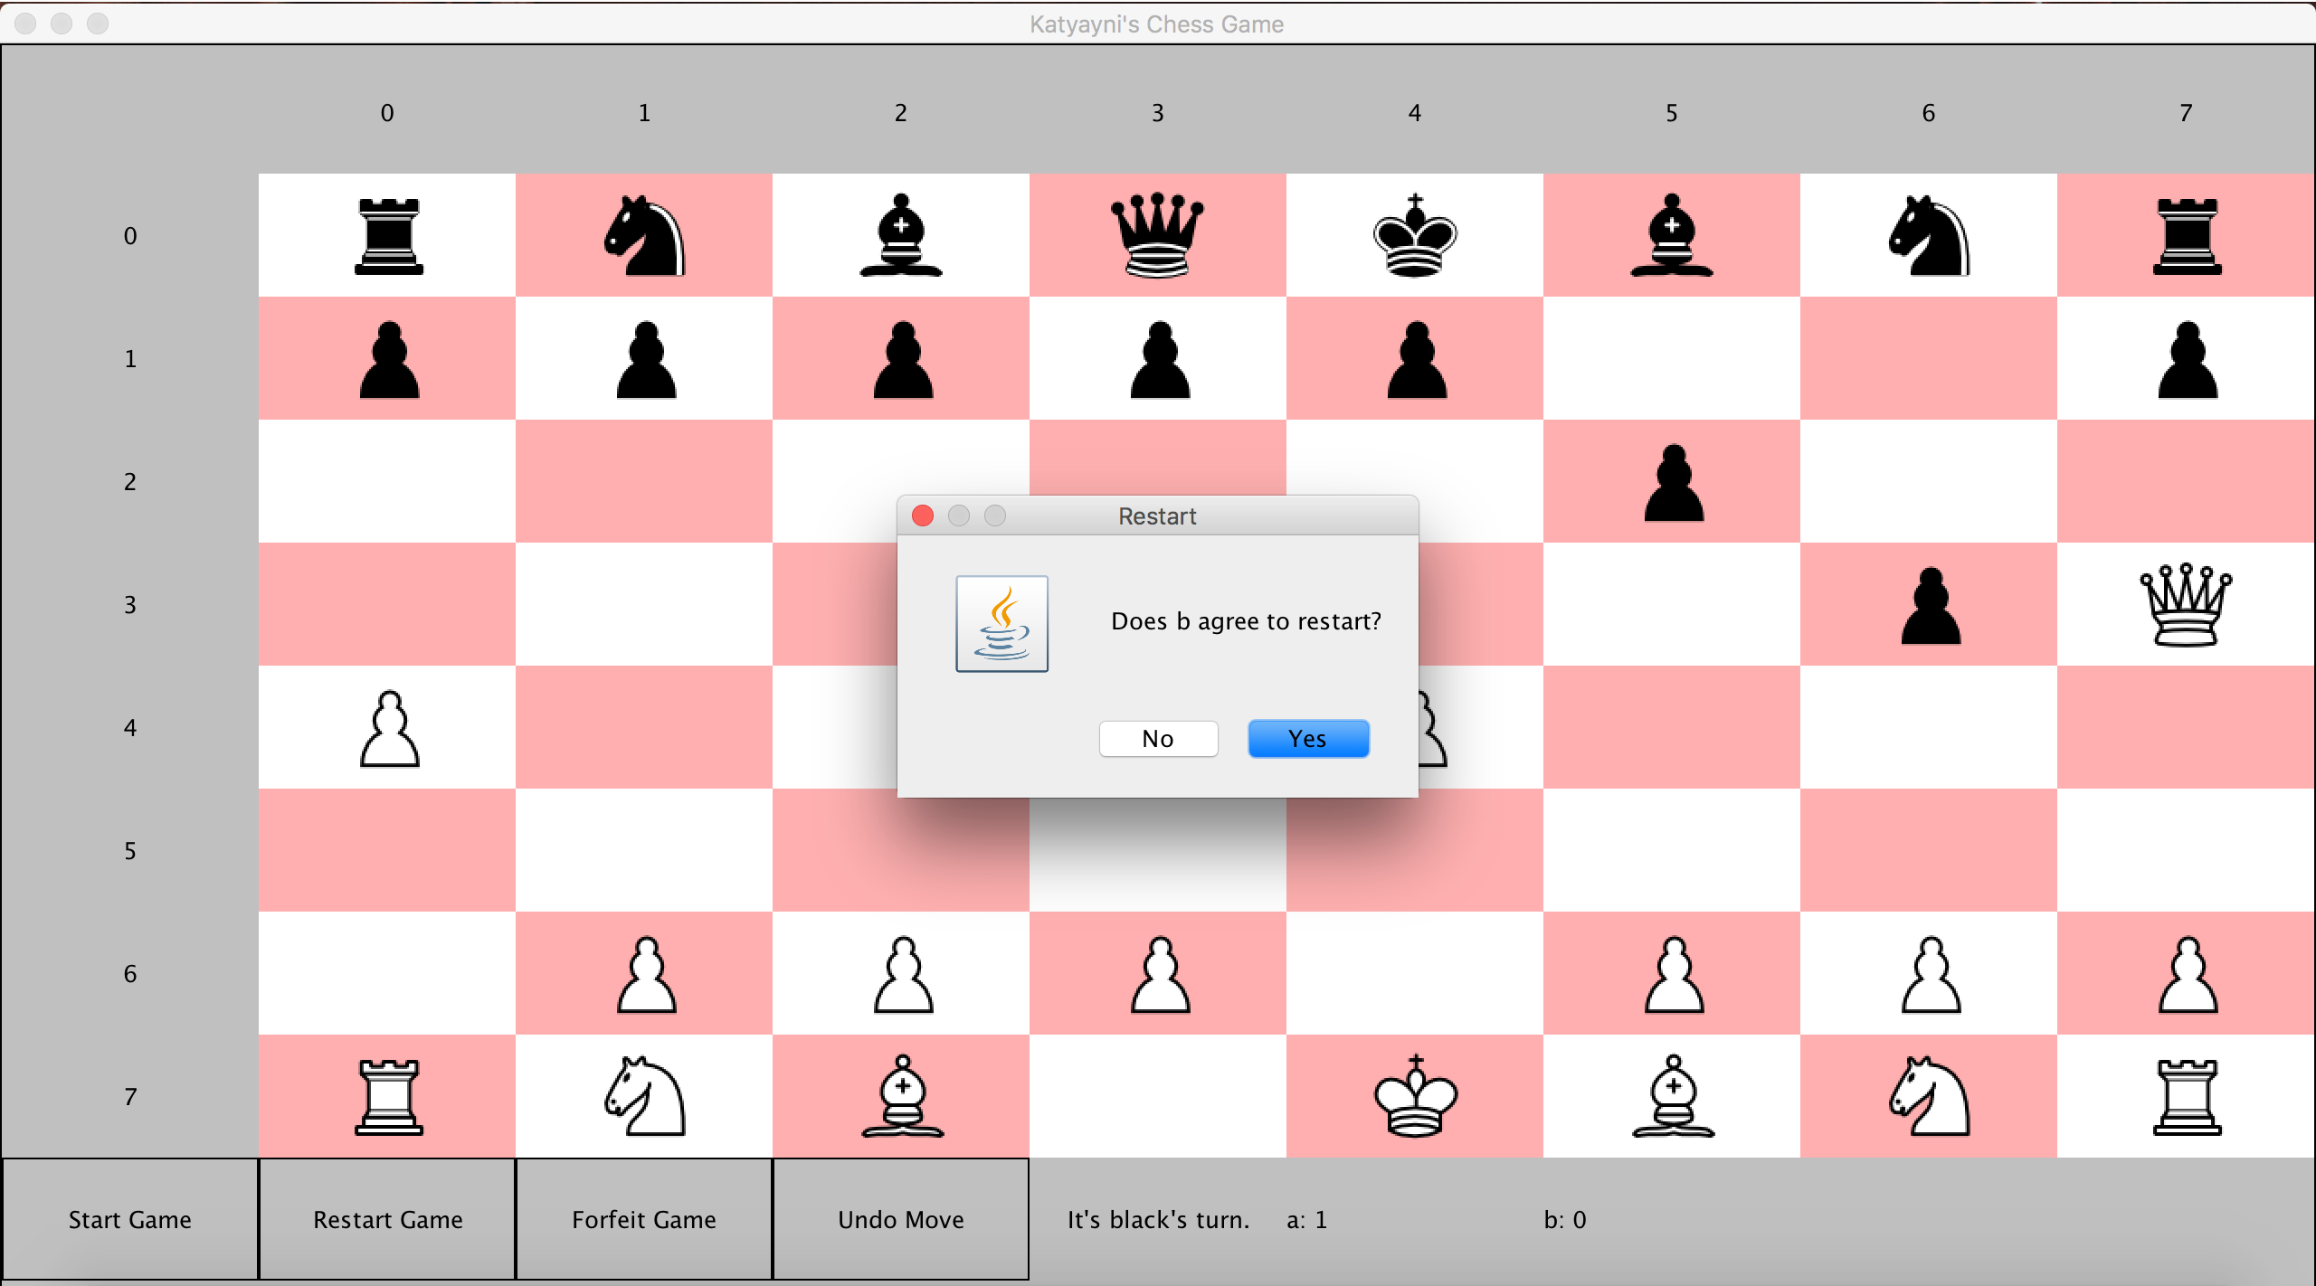

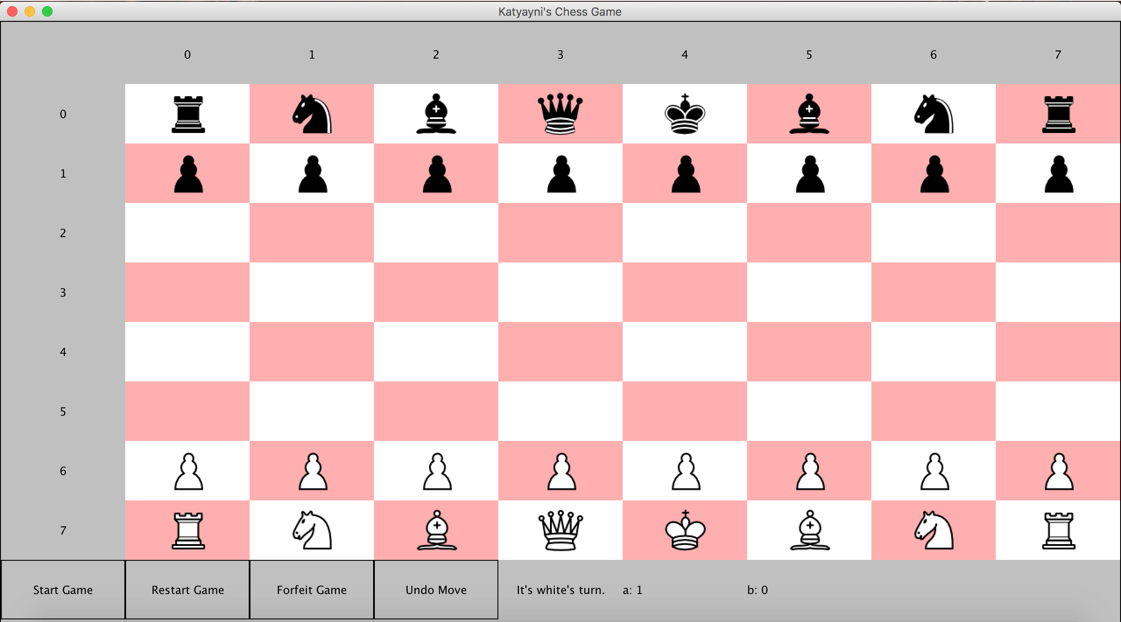

The new game has started with the score from the last game played still updated.

1. The undo move button allows a player to undo a move before their opponent makes a move except for in the case when the game has ended.

In this scenario, the Queen will make the move to capture the pawn.

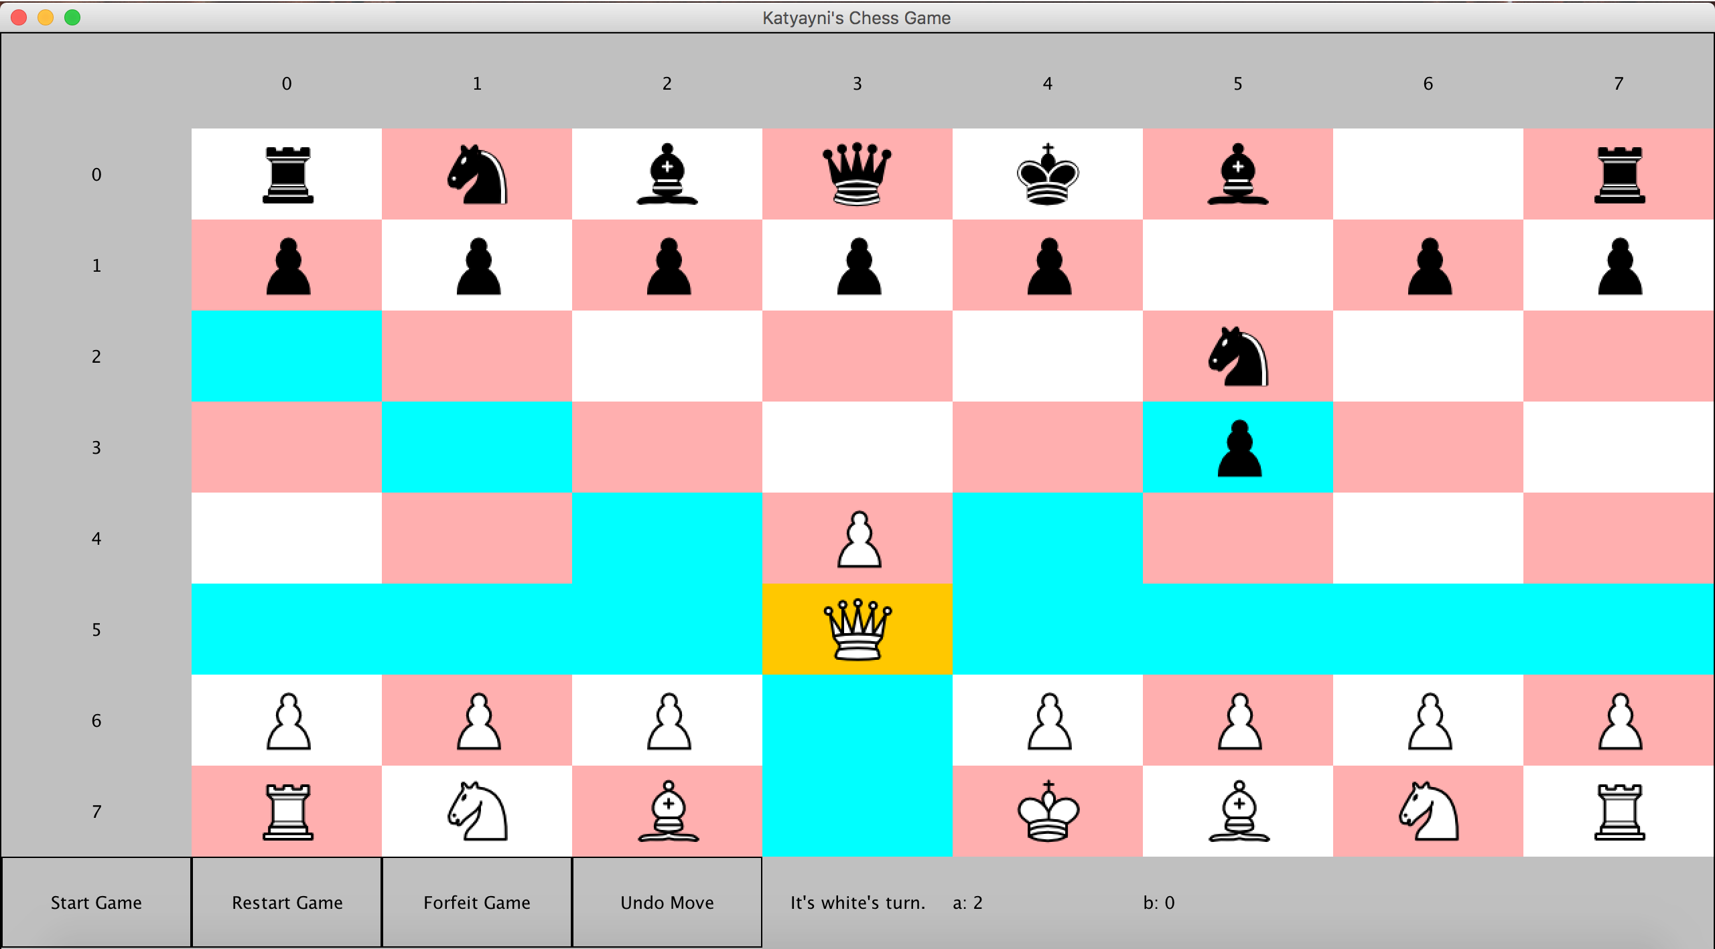

The Queen captures the pawn and the turn is now Black’s turn.

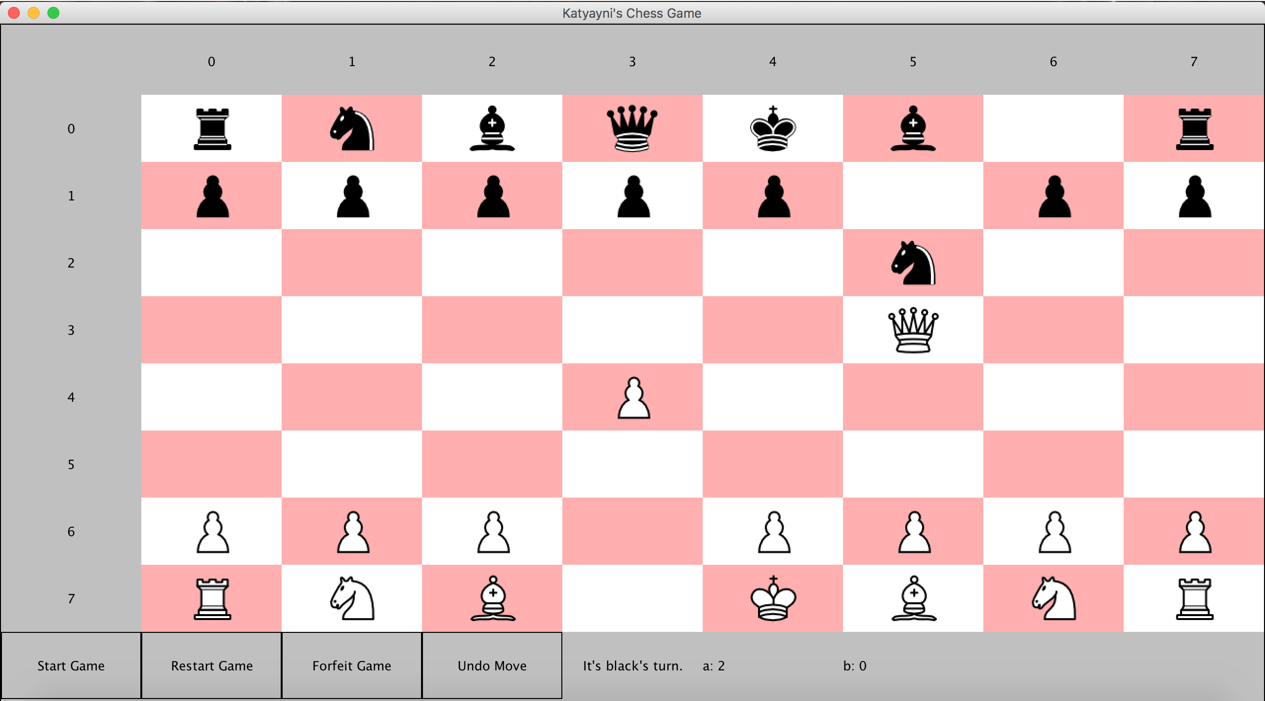

Assuming the White team wants to undo their move, prior to the Black team making their move, they can click Undo Move. Doing so will undo the last move and make is White’s turn again.

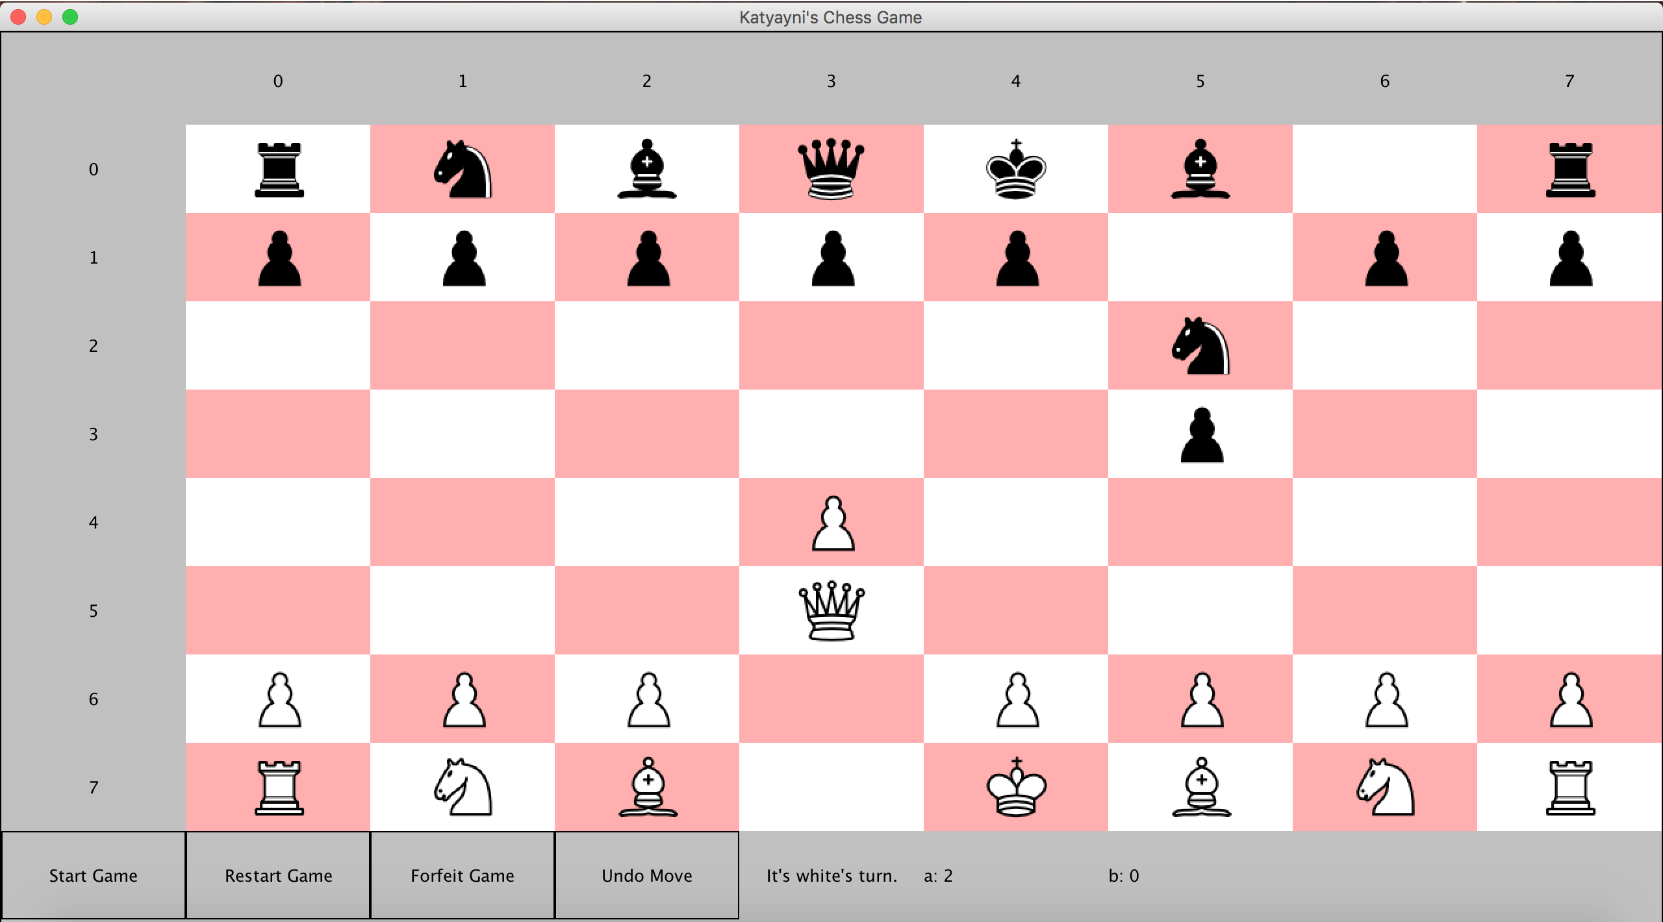

1. Clicking restart game prior to the game ending from a game ending condition will not increase any player’s score.

Prior to clicking Restart Game:



After clicking Restart Game:

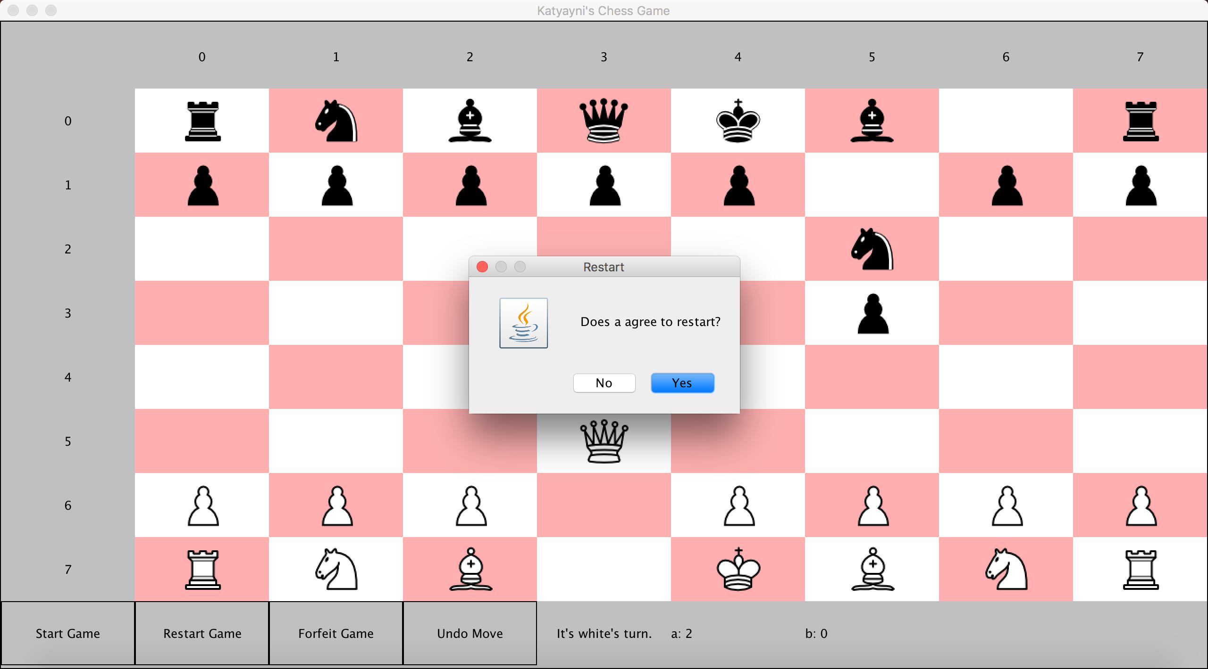

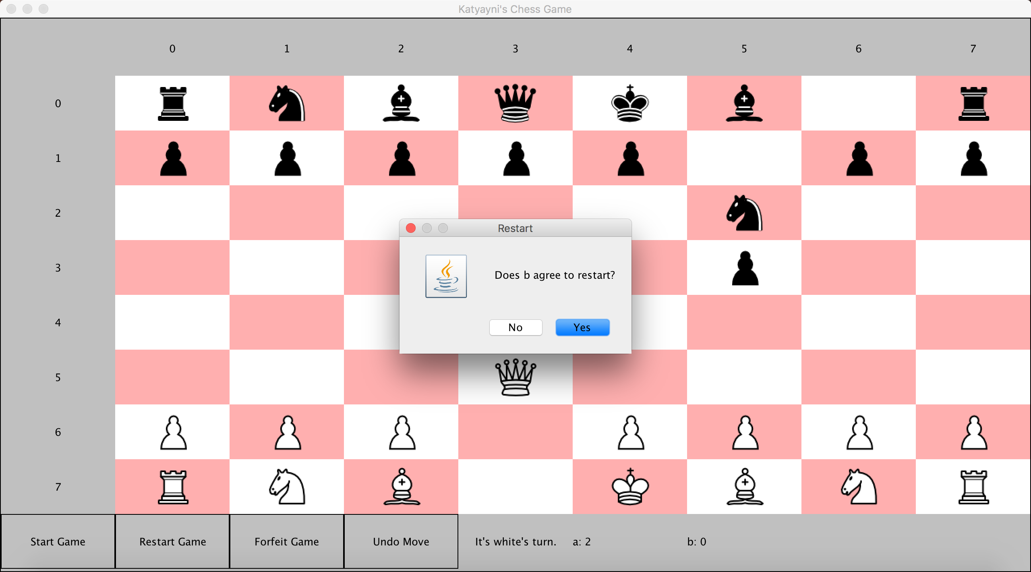

If both players agree, then the board resets.

Notice that the score has not increased.

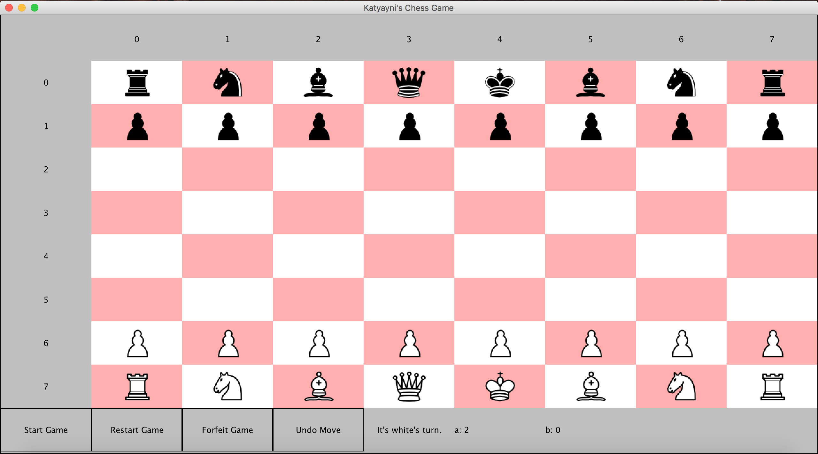

Otherwise, if both players do not agree the following alert appears.

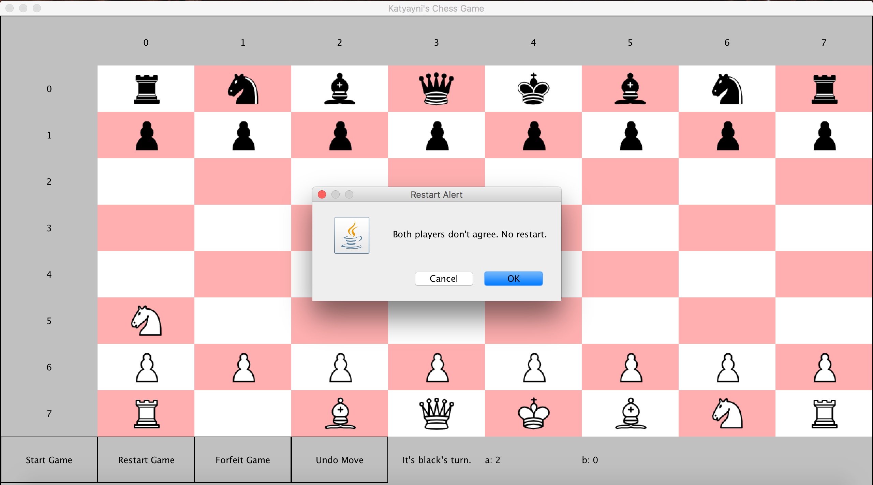

The board will look like the following, with the game continuing.

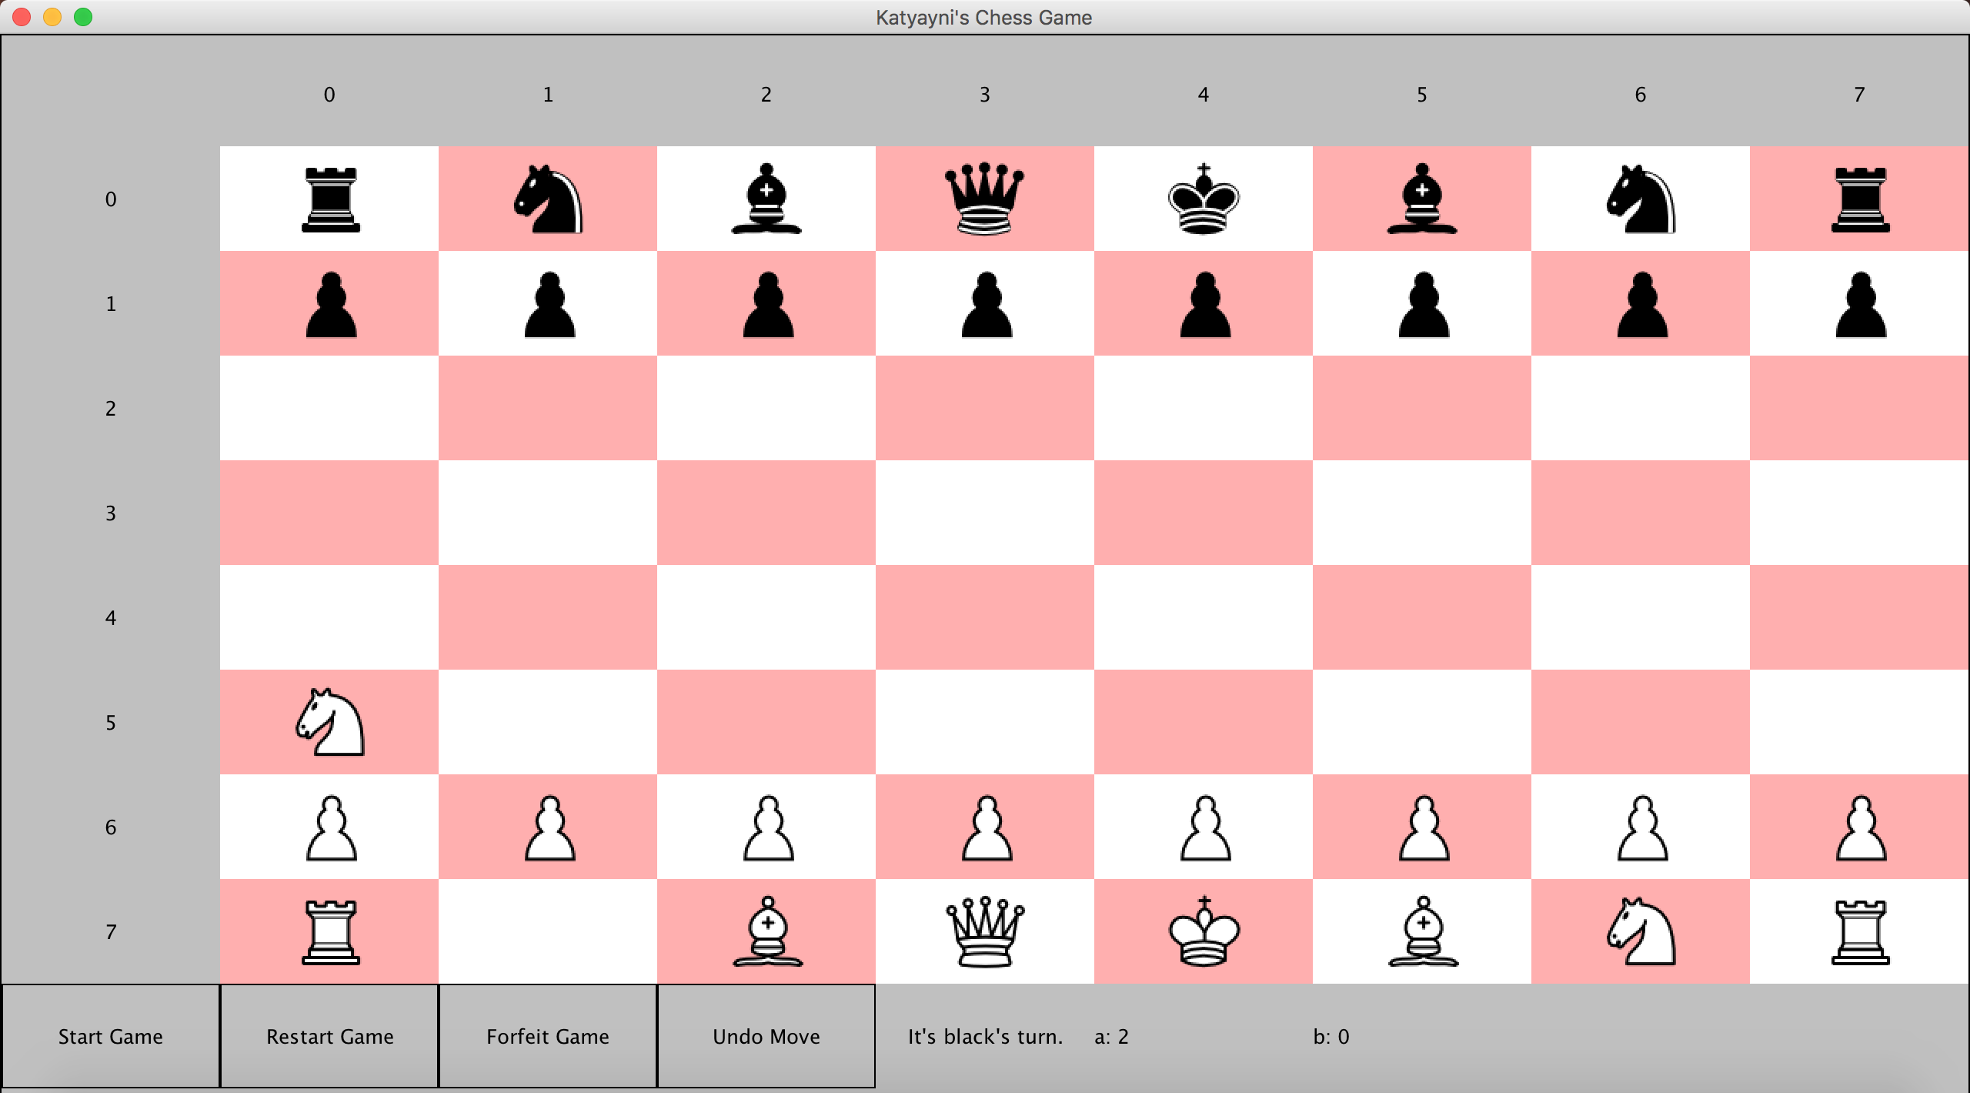

1. Pressing forfeit gives the other team a point and ends the game. If A ended the game, B gets a point.

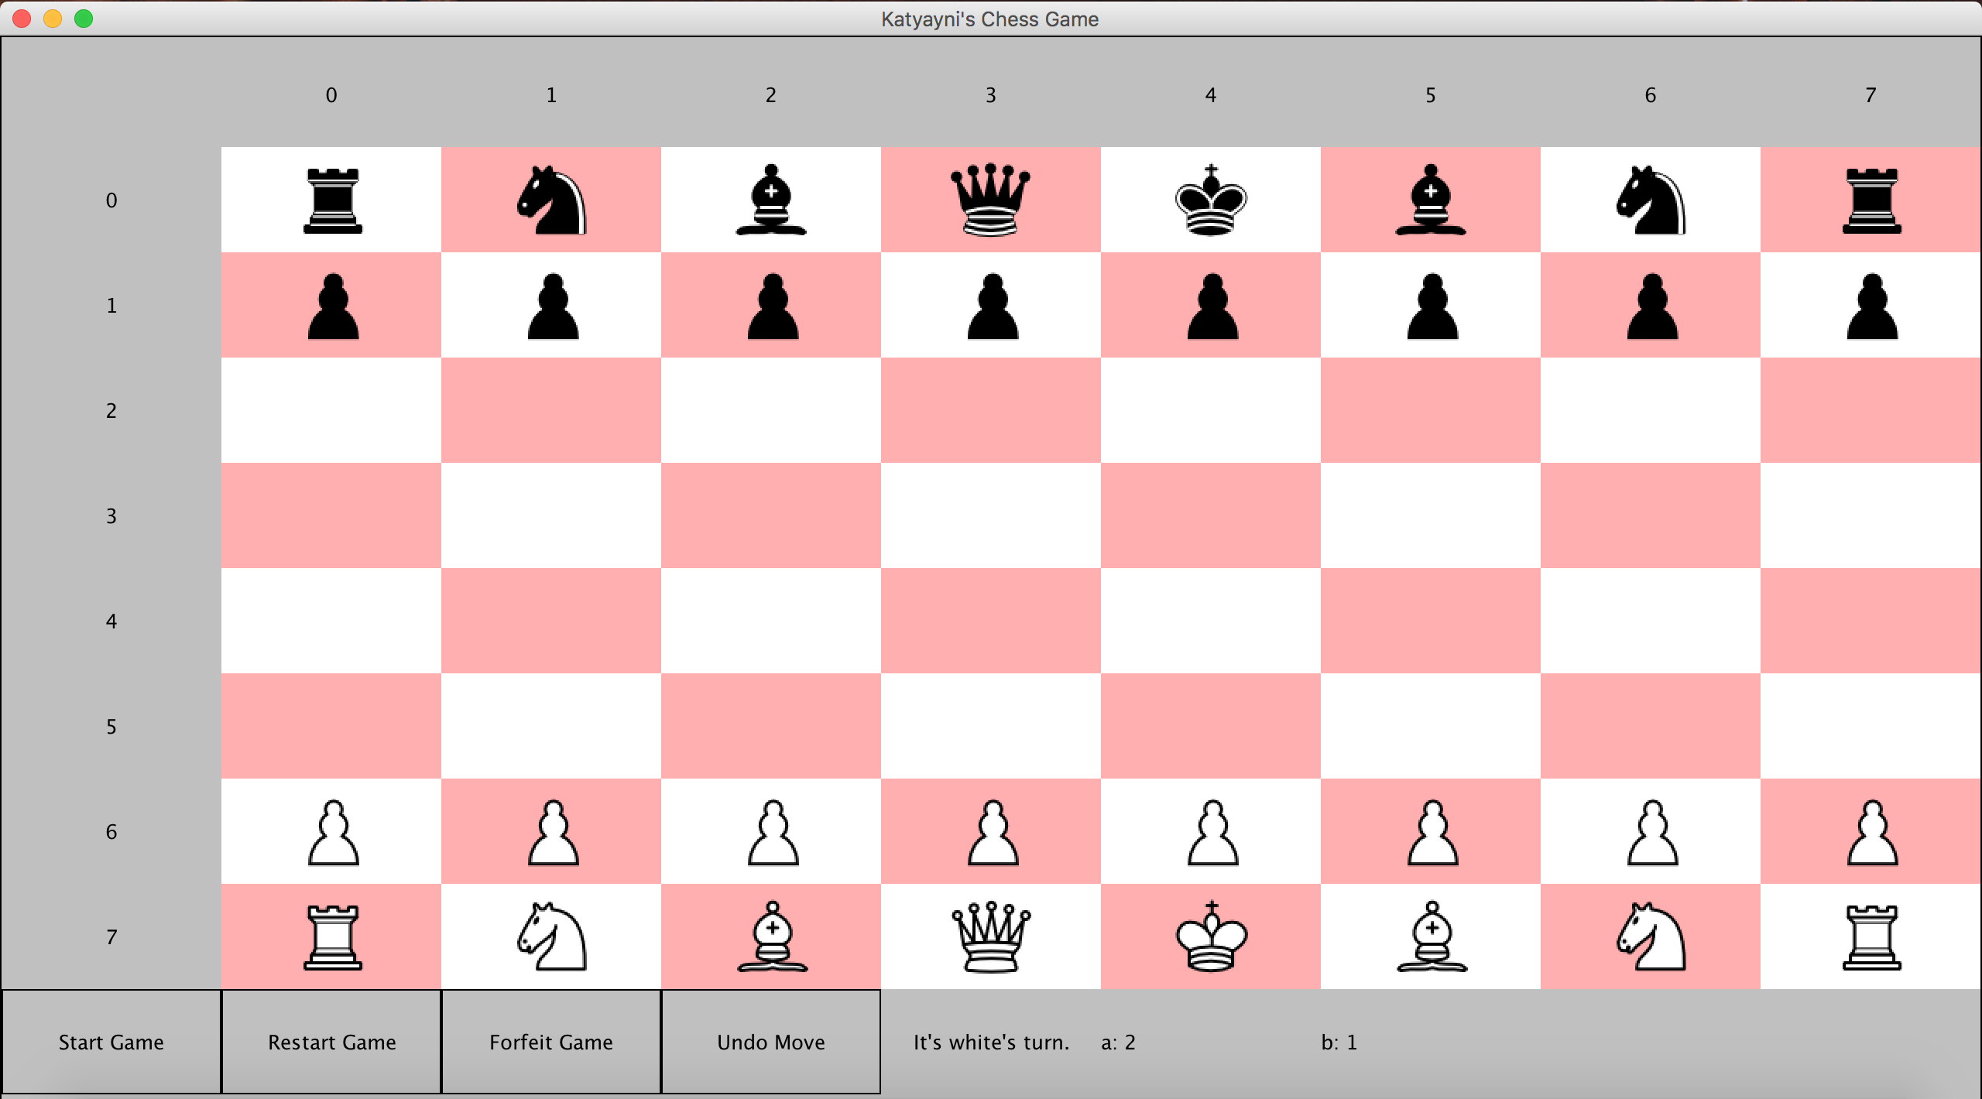

1. All game conditions such as Check, Stalemate, and Checkmate prompt alerts to the user.

